**Human Resource Information System for Department of Interior and Local Government of the Cordillera Administrative Region (DILG-CAR)**

An IT Project Proposal

Presented to the

Faculty of the School of Computing and Information Sciences

Saint Louis University

In Partial Fulfillment

of the Requirements for the Course

IT 411

by

Arvince Neil A. Alcaide

Sarah Mae E. Centino

Denver D. Culbengan

Ryan Christian A. De Guzman

Danielle Phillip A. Estrellado

Aerhielle Cassandra E. Leonen

Paul Christian C. Sam

Benedict M. Suarez

Laurence F. Balmeo

Project Adviser

November 2017

**Abstract**

This proposal is about applying the Human Resource Information System (HRIS) to the Human Resource and Records Section (HRRS) under the Finance & Administrative Division (FAD) of the Department of Interior and Local Government Cordillera Administrative Region (DILG-CAR). The HRRS produce many different forms for their employees and most of the process of making the forms are manually input and edit then print it to send to the employee or other department. The HRRS also update the forms given by the employee and from the Department of Budget and Management (DBM).

The methodology is evolutionary-exploratory model to ensure the understanding of forms and processes to be implement their functions in the system and can show to the HRRS the progress of the system to hear their feedback and to be revise the error of the system.

The HRIS will expect to make the work of the HRRS in the PDS, Leave Application and Ledger, Plantilla, Service Record, NOSI, and NOSA to be more organized, fast, and easy the process of the forms that can benefit both employee and HRRS of the DILG-CAR. It makes the process organize because the system will arrange the parts of the form in a proper order and with guidelines for the HRRS and employees. It will be faster to distribute the forms because it will not be manually written when filling-up the form but it will be fully computerized. It will also make the employee get their forms easier because it is in the system ready to print.

**Table of Contents**

**ABSTRACT …………………………………………………………………………… ii**

**LIST OF FIGURES ………………………………………………………………….. v**

**LIST OF TABLES …………………………………………………………………… vii**

**CHAPTER 1: INTRODUCTION**

1.1 Context of the Study ……………………………………………………… 1

1.2 Background of the Study ………………………………………………… 1

1.3 Statement of the Objectives ……………………………………………… 6

1.4 Scope of the Project ……………………………………………………… 6

1.5 Significance of the Study ………………………………………………… 6

1.5.1 To the Employee ………………………………………………. 6

1.5.2 To the HRRS ……………………….………………………….. 6

1.5.3 To the DILG-CAR …………………………………………….. 6

**CHAPTER 2: METHODOLOGY**

2.1 Requirement Gathering ………………………………………………….. 7

2.2 Quick Design …………………………………………………………….. 7

2.3 Building Prototype …………………………...…………………………… 8

2.4 Customer Evaluation …………………………………………………….. 8

2.5 Refactoring Prototype …………………..……………………………….. 8

2.6 Final Product …………………………………………………………….. 8

2.7 Data Gathering …………………………………………………………… 8

2.8 Design Tools …………………………………………………………….. 9

2.8.1 Entity-Relationship Diagram …………………………………. 9

2.8.2 Relationship Database Schema ……………………………….. 9

2.8.3 System Architecture …………………………………………. . 9

2.8.4 Use Case Diagram ……………………………………………. 9

**CHAPTER 3: OUTCOMES AND RESULTS**

3.1 Requirements Specification …………………………………………….. 10

3.1.1 Functional Requirements ……………………………………… 10

3.1.2 Non-Functional Requirements ………………………………… 13

3.2 System Architecture …………………………..………………………… 14

3.3 Use Case Diagram ……………………………………………………… 15

3.4 Data Architecture

3.4.1 Entity-Relationship Diagram …………………………………. 16

3.4.2 Data Schema ………………………………………………….. 17

3.5 Prototypes

3.5.1 Human Resource ……………………………………………… 21

3.5.2 Employee ……………………………………………………… 33

3.5.3 Super User ……………………………………………………... 38

**APPENDIX**

Appendix A. Daily Time Record …………………………………… 43

Appendix B. Type of Leaves ……………………………………….. 44

Appendix C. Type of Leaves ……………………………………….. 45

Appendix D. Application for Leave Form ………………………….. 46

Appendix E. Computation of Leaves Credit ………………………. .. 47

Appendix F. Computation of Leaves Credit ………………………… 48

Appendix G. Service Record ………………………………………… 49

Appendix H. Notice of Step Increment ……………………………... 50

Appendix I. Notice of Salary Adjustment …………………………… 51

Appendix J. Leave Ledger Card ……………………………………… 52

Appendix K. Personal Services Itemization and Plantilla of Personnel.. 53

Appendix L. Personal Data Sheet …………………………………… 54

Appendix M. Personal Data Sheet ………………………………….. 55

Appendix N. Personal Data Sheet …………………………………... 56

Appendix O. Personal Data Sheet …………………………………… 57

**REFERENCES** …………………………………………………………….. 58

**List of Figures**

Figure 1. HRRS Organizational Chart …………………………………………………… 2

Figure 2. Evolutionary-Exploratory Model ……………………………………………… 7

Figure 3. System Architecture …………………………………………………………… 14

Figure 4. Use Case Diagram …………………………………………………………….. 15

Figure 5. Entity-Relationship Diagram ………………………………………………… 16

Figure 6. Log In ………………………………………………………………………… 21

Figure 7. Human Resource Administrative Officer Dashboard ………………………… 21

Figure 8. Employees Account ………………………………………………………….. 22

Figure 9. PDS Update ………………………………………………………………….. 22

Figure 10. PDS Update ……………………………………………………………….... 23

Figure 11. Pending Employee ………………………………………………………….. 23

Figure 12. Pending Employee ………………………………………………………….. 24

Figure 13. Employee …………………………………………………………………… 24

Figure 14. Employee Profile …………………………………………………………… 25

Figure 15. Generate Report Employee ………………………………………………… 25

Figure 16. Edit Report …………………………………………………………………. 26

Figure 17. Edit Report …………………………………………………………………. 26

Figure 18. Reports ……………………………………………………………………... 27

Figure 19. Reports Certificate of Employment ………………………………………… 27

Figure 20. Reports Certificate of Employment ………………………………………… 28

Figure 21. Pending Leave ……………………………………………………………… 28

Figure 22. Application for Leave ……………………………………………………… 29

Figure 23. Plantilla ……………………………………………………………………. 29

Figure 24. Plantilla Salary Grade ……………………………………………………… 30

Figure 25. Previous Salary Grade ……………………………………………………… 30

Figure 26. Addition of Salary Grade …………………………………………………… 31

Figure 27. Plantilla Division …………………………………………………………… 31

Figure 28. Editing of Plantilla …………………………………………………………. 32

Figure 29. Plantilla Re-assign …………………………………………………………. 32

Figure 30. Archiving an Employee ……………………………………………………. 33

Figure 31. Sign-up …………………………………………………………………….. 33

Figure 32. Employee Dashboard ……………………………………………………… 34

Figure 33. Profile ……………………………………………………………………… 34

Figure 34. Personal Data Sheet ……………………………………………………….. 35

Figure 35. Edit Personal Data Sheet ………………………………………………….. 35

Figure 36. Application Leave Form ………………………………………………….. 36

Figure 37. Leave Summary …………………………………………………………… 36

Figure 38. Service Record ……………………………………………………………. 37

Figure 39. Notification ……………………………………………………………….. 37

Figure 40. Super User Dashboard ……………………………………………………. 38

Figure 41. Super User Dashboard …………………………………………………….. 38

Figure 42. Super User Dashboard …………………………………………………….. 39

Figure 43. List of Employee ………………………………………………………….. 39

Figure 44. Employee Form …………………………………………………………… 40

Figure 45. Employee's Personal Data Sheet …………………………………………… 40

Figure 46. Plantilla Division …………………………………………………………… 41

Figure 47. Plantilla …………………………………………………………………….. 41

Figure 48. Pending and Approved Leaves …………………………………………….. 42

Figure 49. Leave Report ………………………………………………………………. 42

**List of Tables**

Functional Reguirements ……………………………………………………………… 10

**Chapter 1: Introduction**

* 1. **Context of the Study**

Human Resource Information System (HRIS) is a system used to acquire, store, manipulate, analyze, retrieve and distribute information regarding a section like Human Resources by providing ease in compiling and finding certain documents in future need within the organization.

In a typical government office, documents are considered a very important matter, this includes salary records, reports, budget for the project, grievance dispute and other more. These documents are thoroughly created and processed to avoid errors. Consequently, this project focuses on Human Resource and Records Section (HRRS) of the Department of Interior and Local Government of Cordillera Administrative Region (DILG-CAR). HRRS is a section that handles the informational documents of the company which represents the memory of an organization providing tangible evidences of an organization activities and transactions, employee benefits, redeployment, termination, job description, information of employees and the likes.

DILG-CAR assists and advise the president promulgation of policies, regulation, programs and projects to promote peace and order, close general supervision for local governments, promotion of autonomy and community empowerment with a consistent monitor of compliance thereof. Furthermore, DILG-CAR functions in organizing and training primarily for the performance of police functions, a police force that is national in scope and civilian in character. With the use of the information maintain and handheld by the HRRS it strengthens the decision making of DILG-CAR, it will support on how DILG-CAR will act with regards to the matter.

* 1. **Background of the Study**

HRRS is under the Finance and the Administrative Division (FAD) of the DILG-CAR that handles the different forms used by the regional office when it comes to their human resources. This includes the Personal Data Sheet (PDS), Daily Time Record (DTR), Service Records, Notice of Step Increment (NOSI), Notice of Salary Adjustment (NOSA), Leave Ledger Card, Application for Leave of the employee and the Personal Services Itemization and Plantilla of Personnel (PSIPOP) or Plantilla of the DILG-CAR.

DILG-CAR HRRS still uses manual processes in their current system with the use of productivity tools like Microsoft Word and Excel. Through this productivity tool they manually input the data to store it digitally for information management, it is stored in a way that each employee has different report stored in separate files. In generating the reports, they are also using the productivity tool to manually edit each report for any update or correction and it is done for every employee of DILG-CAR.

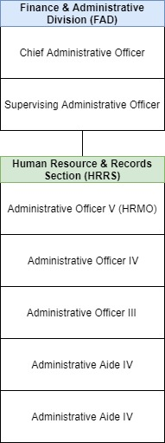

*Figure 1:* HRRS Organizational Chart

The following figure *(see Figure 1)* shows the structure of the HRRS in DILG-CAR and the relations and relative ranks of their positions.

The process performed by the HRRS to maintain the records in the DILG-CAR are the following:

1. Processing of Personal Data Sheet (see Appendix L) – This is where the workflow of HRRS starts, let the employee to fill-out the PDS form which will serve as the profile of the employee of DILG-CAR. The PDS form has four (4) pages, 41 personal information and contains the basic information, past work experiences and the seminars attended by the employee. Once the employee fills-out the form it will be submitted and checked by the Human Resource Administrative Officer (HR Admin Officer), the officer in charge of HRRS.Once it is checked, the HR Admin Officer can return the PDS form to the employee for further correction or revision, and then the HR Admin Officer will keep the form and store it in the filing cabinet. If there is changes to the status of an employee the PDS form can be updated through filling-out another form. It will be required for each employee of DILG-CAR to update their PDS form annually before the HR Admin Officer submits the 201-Report to the Central Office. 201-Report contains all the information about an employee.
2. Processing of Employee’s Work Time – Recording the arrival and departure time of an employee in DILG-CAR is another function of HRRS. DILG-CAR offers a biometric system for recording the DTR (see Appendix A.) of an employee, the biometric system uses the fingerprint of an employee to identify the employee and record its arrival time or departure time. DTR is the form where it summarizes the presence of an employee in a month with regards to its attendance, it is the form where you can find whether an employee is tardy, absent or present on the specific date of the month, DTR is produced every end of the month. When using the biometric system, each employee is required to fill-out the logbook, wherein the employee manually records their arrival and departure time, name and signature. The DTR will serve as the basis for computing the leave credits of an employee that will be produced also every end of the month. All throughout the month this is the process on how the DILG-CAR records the DTR of an employee. The use of logbook is to justify the DTR of an employee. The DILG-CAR offers flexible working hours of time, which means they have different working hours per day for the whole working days of the week (e.g. Monday starting is 8am up to 5pm, Tuesday starting is 7:30 up to 4:30pm etc.). Which brings them to the logbook, the DILG-CAR’s biometric system was not programmed to adapt the flexitime of DILG-CAR. The HR Admin Officer will be forced to manually compute the total working hours of an employee for the DTR.
3. Processing of Employee’s Leaves – The DILG-CAR offers different kinds of leaves these are: Paternity Leave, Rehabilitation Leave, Terminal Leave, Special Emergency Leave, Force Leave, Sick Leave, Vacation Leave, Maternity Leave, Magna Carta for Women, Study Leave, Special Privilege Leave, Solo Parent Leave, Monetize Leave and Violence Against Women and Children Leave. Those are the kinds of leave, an employee can apply for, the process starts by manually filing an application for leave. The HR Admin Officer will let the employee fill-out the form, after that when the employee is finished filling-out the form the employee shall submit the form to the officer for verification. An application for leave is to be verified by officer and the Regional Director (RD). Once the officer approves, the form will be sent to RD for final approval, once it is disapproved it will be resent to the employee for revision and the employee can file another form until it is approved by the two (2) officer in charge. There are some circumstances that the employee will cancel the application for leave, which will be done manually by the officer.
4. Processing of Employee’s Leave Credits – Leave credits will be consumed when the employee files an application for leave and renders the given leave, it is earned every last working day of the month. Once the leave credits are not used it will accumulate and will be converted into cash, once the employee files a resignation letter. Just in case the employee files sick leave and the employee does not have enough leave credits, the employee is allowed to borrow leave credits from vacation leave credit, but not vice versa. If there are no left leave credits left in the employee’s vacation leave, it will be deducted to the employee’s salary. The computation of leave credits is done manually by the HR Admin Officer. It is stored in a spreadsheet file entitled Leave Ledger Card (see Appendix J), it is the form where the points of every employee of the DILG-CAR is stored. In computing leave credits HR Admin Officer needs to refer to the following forms which are the DTR and Leave Form of each employee.
5. Updating of the Plantilla – The Plantilla (see Appendix K) is being released by the Department of Budget and Management (DBM) every start of the year and will be use by the HR Admin Officer all throughout the year. Afterwards the HR Admin Officer will send an updated version of the Plantilla to the DBM every end of the year for documenting purposes. The Plantilla is a form that monitors the employee status in the DILG-CAR, it is a form that holds the entire population of DILG-CAR employee. Every time an individual employee is either promoted or re-assigned, plantilla is updated. If there are changes within Plantilla, it will be reflected on the reports connected in the Plantilla such as PDS and Service Record. Changes made in the Plantilla are done manually using a spreadsheet. The HR Admin Officer often uses the cut and paste method, this is to obtain the information of a certain employee in the Plantilla, this is done to transfer the employee’s information to the designated vacant position in the Plantilla. Using spreadsheet makes the process of promoting and re-assigning difficult, because in every Division of the Plantilla in DILG-CAR it needs different spreadsheet files. When an update occurs the HR Admin also needs to manually update the forms related to the Plantilla. The updated version of the Plantilla will be submitted by the HR Admin Officer to the DBM through the Government Manpower Information Systems (GMIS) official website.
6. Processing of Employee’s Service Record, NOSI and NOSA– Service Record is another kind of form, which serves as a summary of the whole working experience of a government employee in the DILG-CAR. This form can be requested by the employee to be provided by the HR Admin Officer, it will be done by using word processing tools. The Service Record is stored in a way that each employee of DILG-CAR has its own word processing file entitled to the employee’s name. Data from the Service Record is retrieved from the Plantilla, which means that if the employee is promoted or reassigned in Plantilla the Service Record of that employee is to be updated as well. The release of NOSA or NOSI is another factor of updating the Service Record. Updating forms of DILG-CAR will be difficult because of the probability that a change in the Plantilla may affect the information with regards to the forms that is connected to another form making the whole process complicated. NOSA is a Notice of Salary Adjustment and NOSI is a Notice of Step Increment. The two (2) forms will serve as a proof of adjustment or increase on the salary of every employee of DILG-CAR, if the employee will be promoted, the HR Admin Officer will release a NOSI to inform the employee about the changes in their salary. While NOSA is released by the government to inform every employee regarding their salary adjustment, it will only happen once the National Budget Circular of the DBM order for salary adjustment. The NOSA is given by DBM to the HR Admin Officer and will be given to each employee. NOSI happens once the employee is qualified for a promotion that happens once an employee completed a three (3) years of working service on the same position. There will be an addition to the salary of the employee if there is a promotion and a step increment. Salary Grade is the table that contains the different levels of salary an employee can have, starting from salary grade 1 to salary grade 28. This two (2) forms are produced via a word processing tool, the DBM will produce a template and the HR Admin Officer will edit this form manually for every employee of DILG-CAR.
   1. **Statement of the Objectives**

The Objective of the project is to develop a HRIS to automate manual working related processes between Employee and the Human Resource Administrator, and improve monitoring and checking of processes by the Human Resource for DILG-CAR.

* To collect and determine the requirements by gathering data that is significant in the development of the HRIS System
* To establish this different architecture and models in designing the system which are the Application and System Architecture, Entity Relationship Diagram and Data Schema
* To implement the system design by using different tools and technologies, subjecting the proposed system to feature and functional testing and performing beta testing with the different users of the system
* To design the system deployment plan
  1. **Scope of the Project**

The proposal of this project is to improve the system of the HRRS in the DILG-CAR. The developers conducted a requirement elicitation and analysis of the current condition of the regional office of DILG-CAR to collect data needed for the functional requirements of the HRIS for DILG-CAR and the following processes are observed as follows; processing of Personal Data Sheet, processing of employee's work time, processing of employee's leaves, processing of employee's leave credits, maintaining of the Plantilla, processing of employee's Service Record, NOSI, and NOSA. The propose system will not include the Daily Time Record of the employee.

* 1. **Significance of Study**

**1.5.1 To the Employee**

It would help the employees conveniently do work transactions. The application leave as well as the Personal Data Sheet (PDS) will be computerized. The process of filing leave and updating their own PDS will be faster.

**1.5.2 To the HRRS**

It would help the human resource personnel facilitate all the transactions more efficient. It would also gather and track personal information easier to prevent from duplication.

**1.5.3 To the DILG-CAR**

It would help the DILG-CAR reach employees and make their work more accessible. It will also be helpful in keeping track all the employee’s information and monitor all their work transactions.

**CHAPTER 2**

**Methodology**

The methodology that the developers will use for the development of the system is the Evolutionary-Exploratory Model. With requirements that is constantly changing throughout the development of the system using the model is suitable for the project. By using this model, the developers will be able to understand much better the process and purpose of each part in different forms of the HRRS to make development more effective. Through analyzing the gathered data, frequent interviews with the HRRS and observing the current process the developers narrow down the essential requirements, and create features and modules. The developers have designed a diagram to explain the phases for the development of the system.

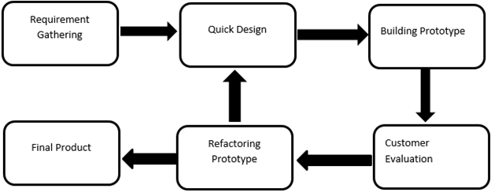

*Figure 2:* Evolutionary-Exploratory Model

With the phases of the model *(see Figure 2)* the developers are improving and making changes with every iteration that is being made thus achieving the desired final product.

**2.1 Requirement Gathering**

In the requirement gathering phase allows the developers to identify processes of the HRRS in DILG – CAR. The information about each process must be identified, a situation where problems occur, different forms with their respective procedure and other information that is necessary to understand by the developers. Document analysis, data gathering, observation of process and interview are the source of information that will be used by the developers for the project.

**2.2 Quick Design**

In the quick design phase, the developers create, design the back-end and the front-end of the system. This design is based from the requirements that will be gathering in the requirement phase and the requirement or suggestion of the HRRS.

**2.3 Building Prototype**

The prototype phase is the start of development of the quick design that is created by the developers. The developers will develop the prototype based on the current requirements and data gathered. The developers work both front-end and the back-end of the system.

**2.4 Customer Evaluation**

The client evaluation phase is where the client evaluates the system created by the developers. The person who will evaluate are from the HRRS or Regional Information & Communication Technology Unit (RITCTU) of the DILG-CAR. The data will be formed of all possible data that can be tested and wrong data given by the HRRS. The first input right data and follow the correct instruction, then after the whole process is the wrong data will be input and a scenario where mistakes happen to see the result for both right and wrong situations. The client will give the developers feedback about the system. It will be 20 minutes of explaining the progress of the system, 30 minutes or 1 hour and 30 minutes of testing of data input into the system and 10 minutes of recording of the results of the evaluation. It will be one time a week when both developers and client is free.

**2.5 Refactoring Prototype**

The refactoring prototype phase is where the developers refactor or update the system from the feedback from the client. After the client does the evaluation, if the client sees problems, a system error occurs or the client wants minor changes in the system or in some cases the developers found bugs then the developers will list it. Then the developers will fix the problem and the bug, and then present the updated system to the client.

**2.6 Final Product**

After all, the building of a prototype, evaluate, and refactoring to attain the system required, the final product phase will start. In this phase, the developers will present it to the whole employee of the DILG – CAR main office to demonstrate it to them so that they know how to use the system.

**2.7 Data Gathering**

The methods that the developers will use in gathering information are interviews, studying the HRRS current process, analyzed different forms and documents.

The developers will be observing the working area of the HRRS to understand the different processes that are taking place in the working area. The developers, interviewed the Administrative Officer of the HRRS by asking questions like the step by step process of different forms, problems and concerns occur in the office, explanation of different forms relate to other forms, and how the system should process and the outcome of the forms generate by the system. The developers asked the HRRS to recite the documents needed to manage the processes and the generated reports after the process. Sample copies of reports and user records were also collected so that the developers may have a very good understanding about the content and the processes of the client’s work.

The developers looked at the interfaces of ELOPDS which is a sample Information System. This will be the base appearance of the system suggested by the RITCTU. (<http://elopds.dilg.gov.ph/login.php?page=index.php>). It shows the sign-up, sign-in, view table, edit form, and other functions on their website. The RITCTU also give the theme for the system following the color of the logo of DILG.

**2.8 Design Tools**

**2.8.1 Entity-Relationship Diagram**

The Entity-Relationship diagram will be used by the developers to represent the information system for DILG’s daily monitoring of work and to show the relationships between entities in the database.

**2.8.2 Relationship Database Schema**

This will support the ERD used by the developers, it will describe the data or information that is stored in the database. The schema represents the view of the entire database including its constraint to specify the rules for data in a table.

**2.8.3 System Architecture**

System Architecture will be used in the development of the system to define the framework and structure of the organization’s application. It establishes the framework for agility, reliability and scalability in the application system so that the application will respond effectively and efficiently to changes in the important information systems. And it defines the necessary application systems to process data and support solutions for the business requirements. It also shows how this application communicate with each other and to its users.

**2.3.4 Use Case Diagram**

Use Case Diagram will be used in the development of the system to depict the interactions among the elements of the system and to developers to identify, clarify and organize system requirements.

**Chapter 3: Outcomes and Results**

**3.1 Requirements Specification**

**3.1.1 Functional Requirements**

The following are the list of functional requirements provided by the system.

|  |  |
| --- | --- |
| PDS | * The employees will be able to input their personal information in the Personal Data Sheet (PDS) * The employees will be able to modify their personal information in the Personal Information Sheet (PDS) form * The employees will be able to view their personal information (PDS) * The employee will be able to update their personal information (PDS) * The HR Admin Officer will be able to accept or reject the updated Personal Data Sheet of the employee * The HR Admin Officer will be able to generate the PDF file for Personal Data Sheet (PDS) * The Regional Director will be able to view their Personal Information Sheet (PDS) form |
| Leaves | * The employees will be able to input their leave information * The employees will be able to file their leave application * The employees will be able to modify their leave information * The employees will be able to view their leave information * The employee will be able to update their leave information * The HR Admin Officer will be able to input data in the Leave Ledger * The HR Admin Officer will be able to modify leave ledger of employee * The HR Admin Officer will be able to view the pending and approve leaves * The HR Admin Officer will be able to view the Leave Ledger of employee * The HR Admin Officer will be able update the Leave Ledger of employee * The HR Admin Officer will be able to accept or reject employee’s file leave * The HR Admin Officer will be able to print Leave Ledger * The Regional Director will be able to view the Leave |
| Service Record | * The employees will be able to view their Service Record * The HR Admin Officer will be able to input data in the Service Record * The HR Admin Officer will be able to modify Service Record * The HR Admin Officer will be able to view the Service Record of employee * The HR Admin Officer will be able update Service Record of employee * The HR Admin Officer will be able to print Service Record |
| Plantilla | * The HR Admin Officer will be able to input data in the Plantilla * The HR Admin Officer will be able to modify personal information in the Plantilla * The HR Admin Officer will be able to view the Plantilla * The HR Admin Officer will be able to update the Plantilla * The HR Admin Officer will be able to select employee to promote, re-assign, or archive in the Plantilla * The HR Admin Officer will be able to print Plantilla * The Regional Director will be able to view the Plantilla |
| NOSI | * The HR Admin Officer will be able to modify Notice of Step Increment (NOSI) of employee * The HR Admin Officer will be able to view the Notice of Step Increment (NOSI) of employee * The HR Admin Officer will be able update Notice of Step Increment (NOSI) of employee * The HR Admin Officer will be able to print Notice of Step Increment (NOSI) |
| NOSA | * The HR Admin Officer will be able to modify Notice of Salary Adjustment (NOSA) of employee * The HR Admin Officer will be able to view the Notice of Salary Adjustment (NOSA) of employee * The HR Admin Officer will be able update Notice of Salary Adjustment (NOSA) of employee * The HR Admin Officer will be able to print Notice of Step Increment (NOSI) |
| COE | * The HR Admin Officer will be able to view the Certificate of Employment of employee * The HR Admin Officer will be able to print Certificate of Employment of employee |
| HR Features | * The HR Admin Officer will be able to search specific employee profile * The HR Admin Officer will be able to search, view and filter pending employees * The HR Admin Officer will be able to accept or reject employee’s signup request * The HR Admin Officer will be able to add an employee ID * The HR Admin Officer will be able to select a report to generate |

**3.1.2 Non-Functional Requirements**

The following are the list of how the system should be:

* The system must be able to secure privacy of information
* The performance of the system should be fast; there should be no run-time constraints
* The system should provide accurate and precise data
* The system should be easy to operate and learn
* The system should be able to handle error detection and checking of duplicates
* The system should be able to handle capacity of resources and data to be processed

**3.2 System Architecture**

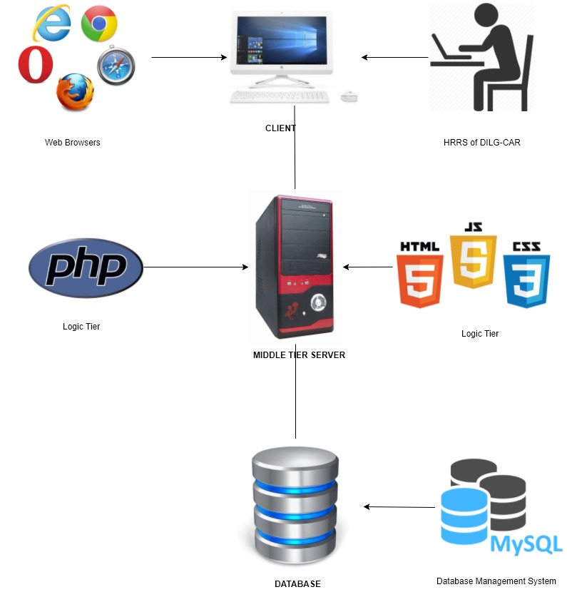

*Figure 3: System Architecture*

The system architecture *(see Figure 3)* presented in the project proposal describes the tools that possibly use in the development phase of the project. Logic Tier can use in the development of the front end of the project, MySQL is the storage of data and serve as the back end of the system, The Human Resource of DILG-CAR can be able to input some data and the data input will be stored in the database, the internet is the main source of so employee in DILG-CAR can be able to used the application and Presentation tier is the web browser it is used to open and run the web application.

**3.3 Use Case Diagram / Site Map / Function Models**

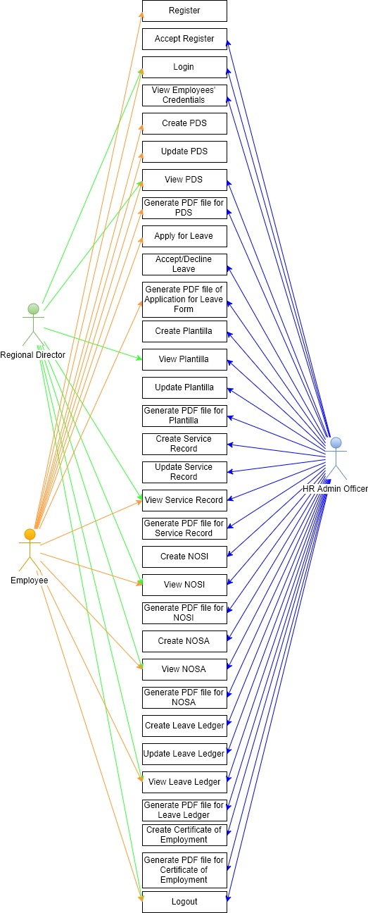

*Figure 4:* Use Case Diagram

The Use Case Diagram *(see Figure 4)* presented describes the set of HRIS actions that can be performed by the employee, HR Admin Officer and the Regional Director of the DILG-CAR.

**3.4 Data Architecture**

**3.4.1 Entity-Relationship Diagram**

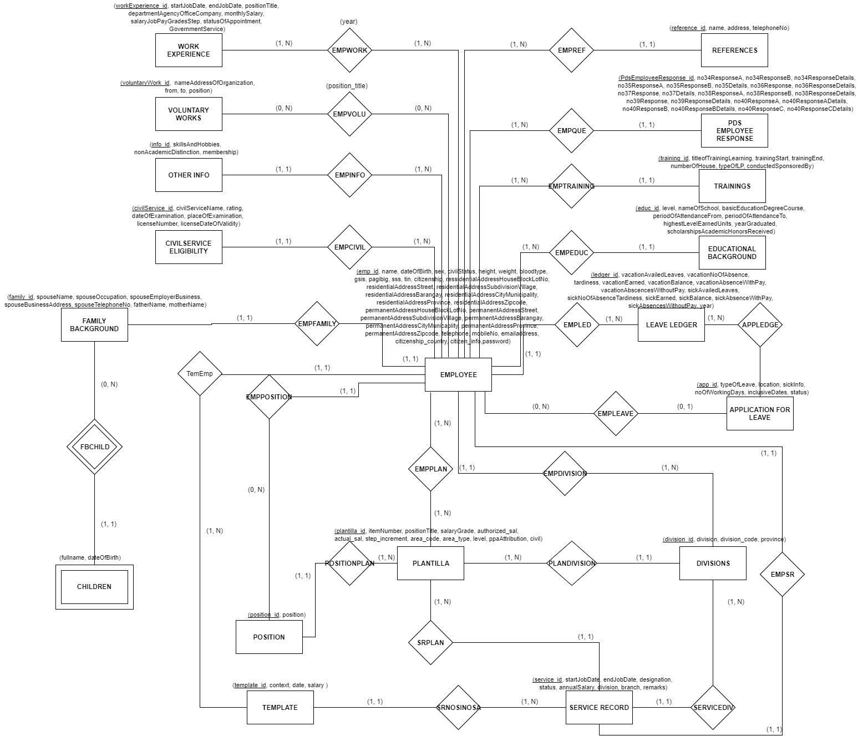

*Figure 5:* Entity-relationship Diagram

The entity-relationship diagram *(see Figure 5)* shows the relationship of entity sets that will be stored in the database of the HRIS.

**3.4.2 Data Schema**

APPLICATION FOR LEAVE (app_id, emp_id, typeOfLeave, location, sickInfo, noOfWorkingDays, inclusiveDates, status)

FK emp_id References Employee Nulls Not Allowed

Delete Cascade, Update Cascade

AK emp_id

CIVILSERVICE ELIGIBILITY (civilService_id, emp_id, civilServiceName, rating, dateOfExamination, placeOfExamination, licenseNumber, licenseDateOfValidity)

FK emp_id References Employee Nulls Not Allowed

Delete Cascade, Update Cascade

CHILDREN (family_id, fullname, dateOfBirth)

FK family_id References FamilyBackground Nulls Not Allowed

Delete Cascade, Update Cascade

DIVISION (division_id, division_code, division, province)

AK division_code

EDUCATIONAL BACKGROUND (educ_id, emp_id, level, nameOfSchool, basicEducationDegreeCourse, periodOfAttendanceFrom, periodOfAttendanceTo, highestLevelEarnedUnits, yearGraduated, scholarshipsAcademicHonorsReceived)

FK emp_id References Employee Nulls Not Allowed

Delete Cascade, Update Cascade

EMPLOYEE (emp_id, name, dateOfBirth, sex, civilStatus, height, weight, bloodtype, gsis, pagibig, sss, tin, citizenship, ressidentialAddressHouseBlockLotNo, residentialAddressStreet, residentialAddressSubdivisionVillage, residentialAddressBarangay, residentialAddressCityMunicipality, residentialAddressProvince, residentialAddressZipcode, permanentAddressHouseBlockLotNo, permanentAddressStreet, permanentAddressSubdivisionVillage, permanentAddressBarangay, permanentAddressCityMunicaplity, permanentAddressProvince, permanentAddressZipcode, telephoneNo, mobileNo, emailaddress, citizenship_country, citizen_info, password)

AK name

EMPVOLU (voluntaryWork_id, emp_id, position_title)

FK voluntaryWork_id References Voluntary Works Nulls Not Allowed

Delete Cascade, Update Cascade

FK emp_id References Employee Nulls Not Allowed

Delete Cascade, Update Cascade

EMPWORK (workExperience_id, emp_id, year)

FK workExperience_id References Work Experience Nulls Not Allowed

Delete Cascade, Update Cascade

FK emp_id References Employee Nulls Not Allowed

Delete Cascade, Update Cascade

FAMILY BACKGROUND (family_id, emp_id, spouseName, spouseOccupation, spouseEmployerBusiness, spouseBusinessAddress, spouseTelephoneNo, fatherName, motherName)

FK emp_id References Employee Nulls Not Allowed

Delete Cascade, Update Cascade

LEAVE LEDGER (ledger_id, emp_id, app_id, vacationAvailedLeaves, vacationNoOfAbsence, tardiness, vacationEarned, vacationBalance, vacationAbsenceWithPay, vacationAbscencesWithoutPay, sickAvailedLeaves, sickNoOfAbsenceTardiness, sickEarned, sickBalance, sickAbsenceWithPay, sickAbsencesWithoutPay, year)

FK emp_id References Employee Nulls Not Allowed

Delete Cascade, Update Cascade

FK app_id References ApplicationForLeave Nulls Not Allowed

Delete Cascade, Update Cascade

AK emp_id

OTHER INFO (info_id, emp_id, skillsAndHobbies, nonAcademicDistinction, membership)

FK emp_id References Employee Nulls Not Allowed

Delete Cascade, Update Cascade

PLANTILLA (plantilla_id, emp_id, position_id, division_id, itemNumber, positionTitle, salaryGrade, authorized_sal, actual_sal, step_increment, area_code, area_type, level, ppaAttribution, civil)

FK emp_id References Employee Nulls Not Allowed

Delete Cascade, Update Cascade

FK position_id References Position Nulls Not Allowed

Delete Cascade, Update Cascade

FK division_id References Division Nulls Not Allowed

Delete Cascade, Update Cascade

AK emp_id

PDS EMPLOYEE RESPONSE (PdsEmployeeResponse_id, emp_id, no34ResponseA, no34ResponseB, no34ResponseDetails, no35ResponseA, no35ResponseB, no35Details, no36Response, no36ResponseDetails, no37Response, no37Details, no38ResponseA, no38ResponseB, no38ResponseDetails, no39Response, no39ResponseDetails, no40ResponseA, no40ResponseADetails, no40ResponseB, no40ResponseBDetails, no40ResponseC, no40ResponseCDetails)

FK emp_id References Employee Nulls Not Allowed

Delete Cascade, Update Cascade

POSITION (position_id, emp_id, position)

FK emp_id References Employee Nulls Not Allowed

Delete Cascade, Update Cascade

REFERENCES (reference_id, emp_id, name, address, telephoneNo)

FK emp_id References Employee Nulls Not Allowed

Delete Cascade, Update Cascade

SERVICE RECORD (service_id, emp_id, startJobDate, endJobDate, designation, status, annualSalary, division, branch, remarks)

FK emp_id References Employee Nulls Not Allowed

Delete Cascade, Update Cascade

AK emp_id

TEMPLATE (template_id, emp_id, context, date, salary)

FK emp_id References Employee Nulls Not Allowed

TRAININGS (training_id, emp_id, titleofTrainingLearning, trainingStart, trainingEnd, numberOfHouse, typeOfLP, conductedSponsoredBy)

FK emp_id References Employee Nulls Not Allowed

Delete Cascade, Update Cascade

VOLUNTARY WORKS (voluntaryWork_id, emp_id, nameAddressOfOrganization, from, to, position)

FK emp_id References Employee Nulls Not Allowed

Delete Cascade, Update Cascade

WORK EXPERIENCE (workExperience_id, emp_id, startJobDate, endJobDate, positionTitle, departmentAgencyOfficeCompany, monthlySalary, salaryJobPayGradesStep, statusOfAppointment, GovernmentService)

FK emp_id References Employee Nulls Not Allowed

Delete Cascade, Update Cascade

**3.5 Prototypes**

**3.5.1 Human Resource Administrative Officer**

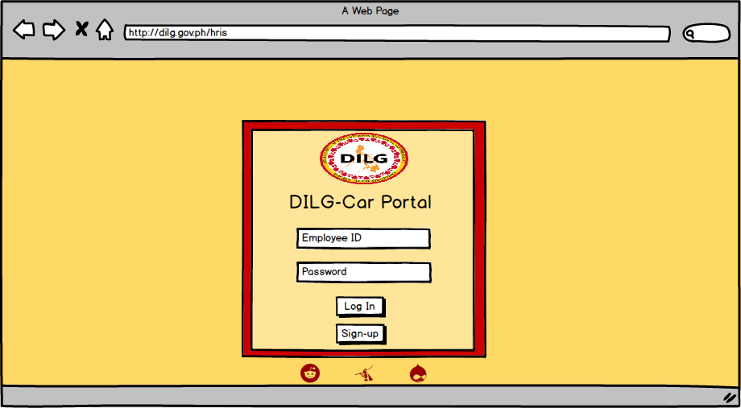

*Figure 6: Log In*

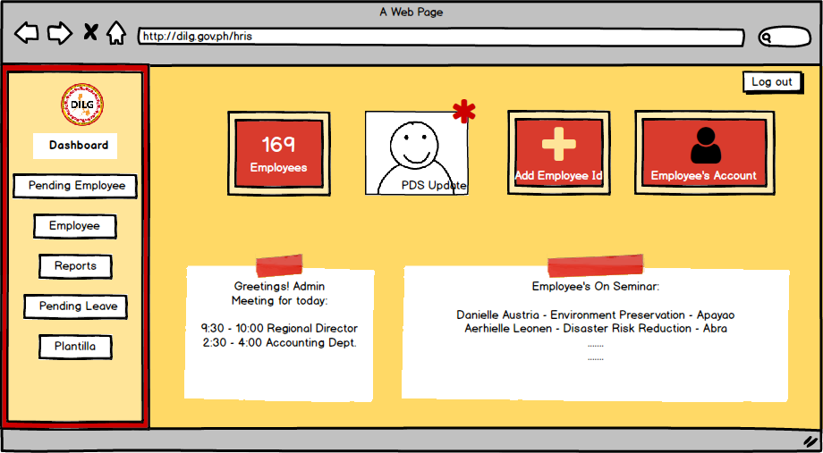

*Figure 7: Dashboard*

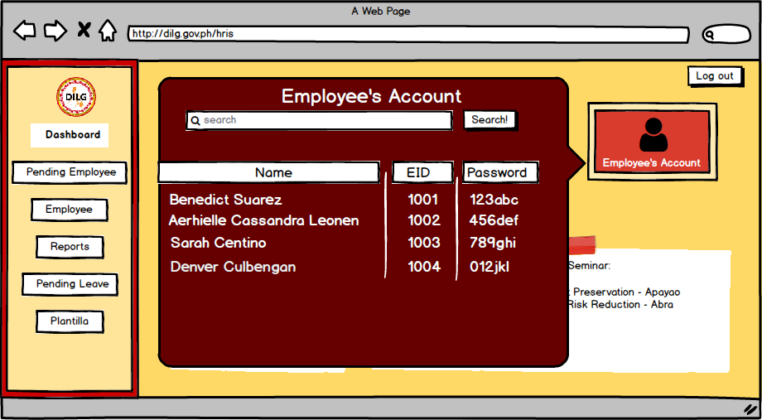

*Figure 8: Employees Account - In this interface the HR can view the credentials of the DILG-CAR employee.*

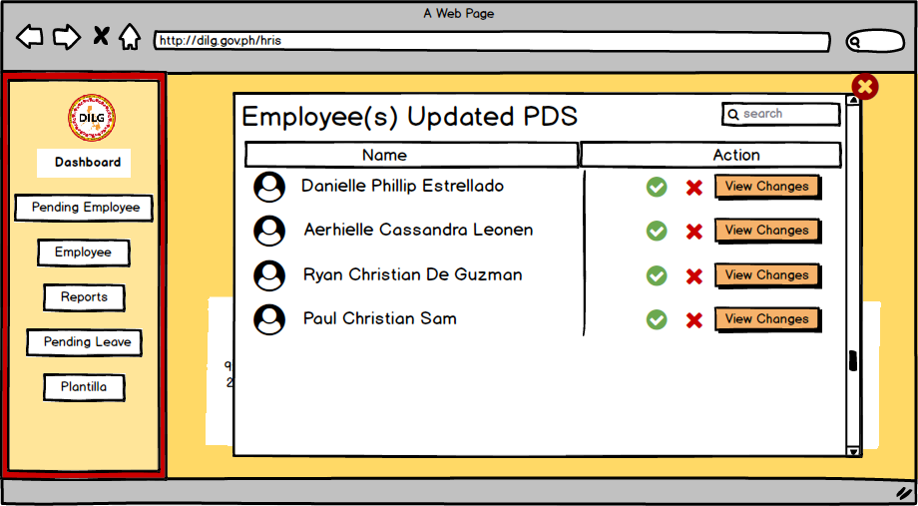

*Figure 9: PDS Update - In this interface the HR can Accept or Reject the employee’s who updated their PDS.*

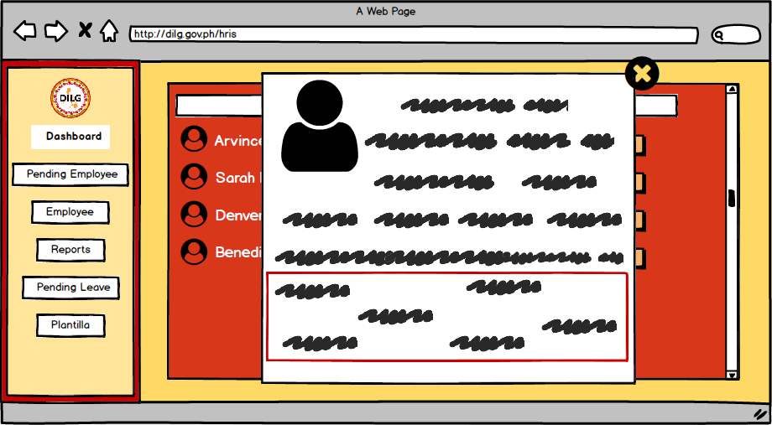

*Figure 10: PDS Update - Information updated by the employee.*

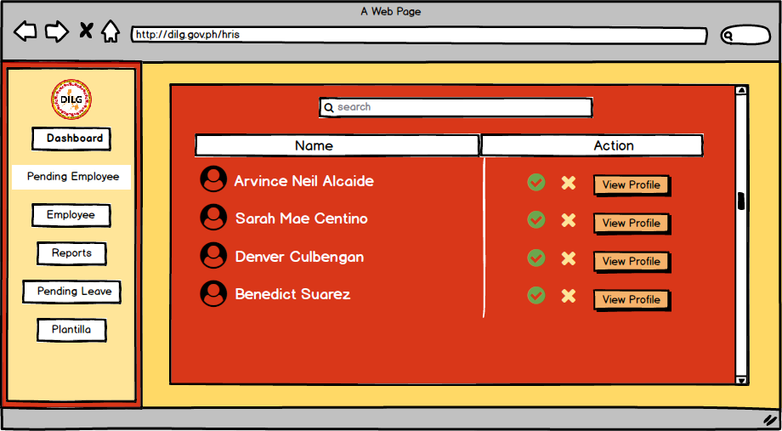

*Figure 11: Pending Employee - In this interface the HR can Accept or Reject the employee who sign up for the system.*

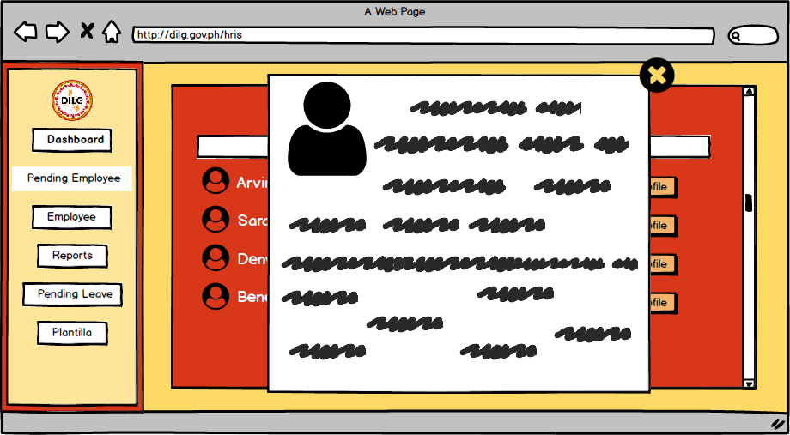

*Figure 12: Pending Employee - The HR can view the profile of the employee who sign up for the system.*

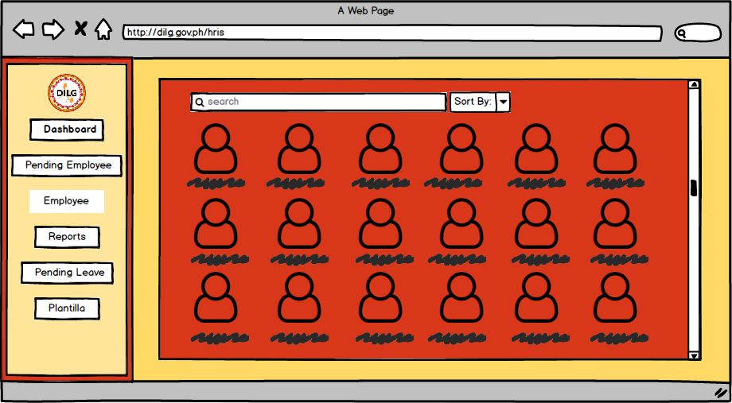

*Figure 13: Employee - This is the interface for the HR to view the currently employed employee of DILG-CAR.*

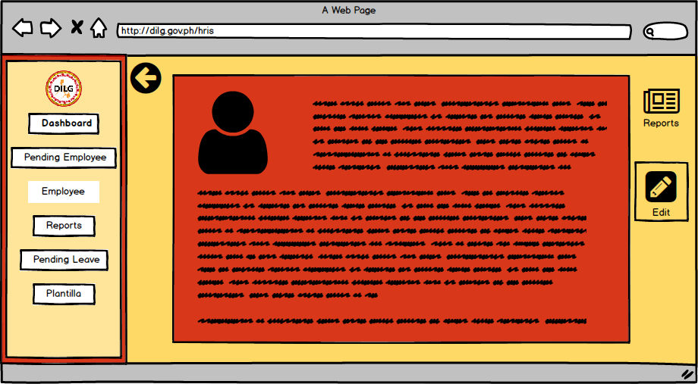

*Figure 14: Employee Profile - The interface to view the profile of an employee.*

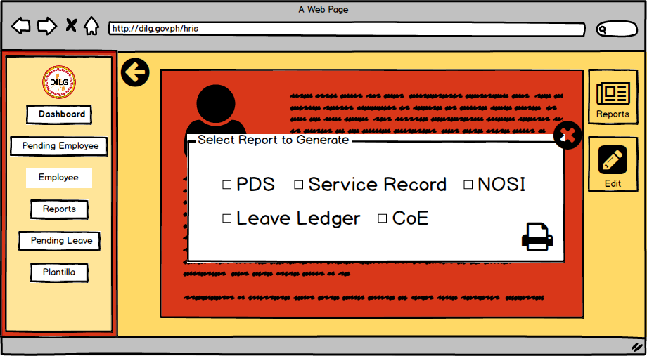

*Figure 15: Generate Report Employee*

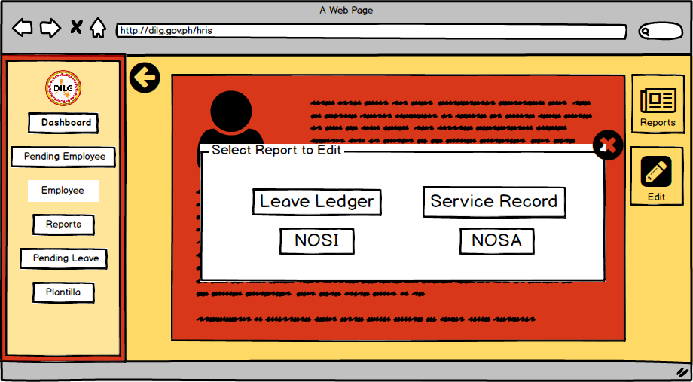

*Figure 16: Edit Report - This is the interface where the employee can edit each report of the employee.*

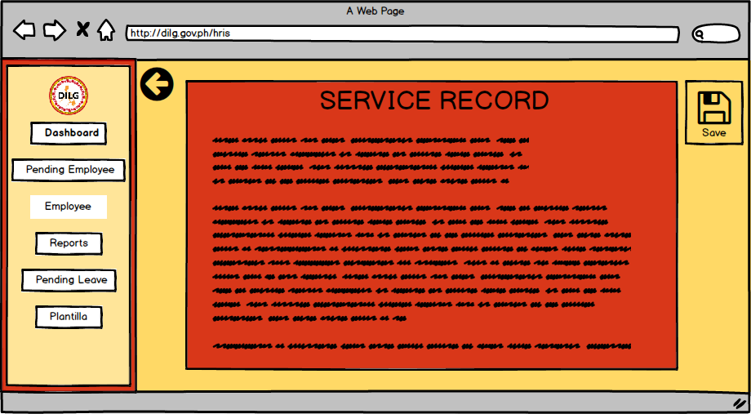

*Figure 17: Edit Report*

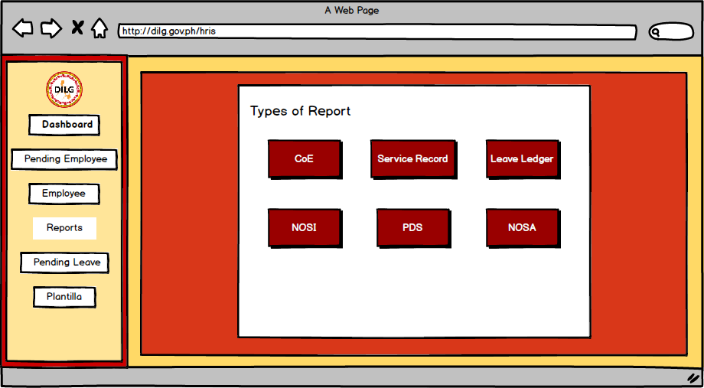

*Figure 18: Reports*

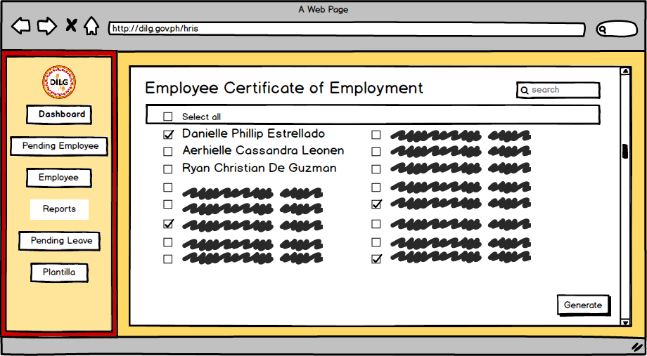

*Figure 19: Reports Certificate of Employment - In this interface the HR can select multiple employee to generate reports.*

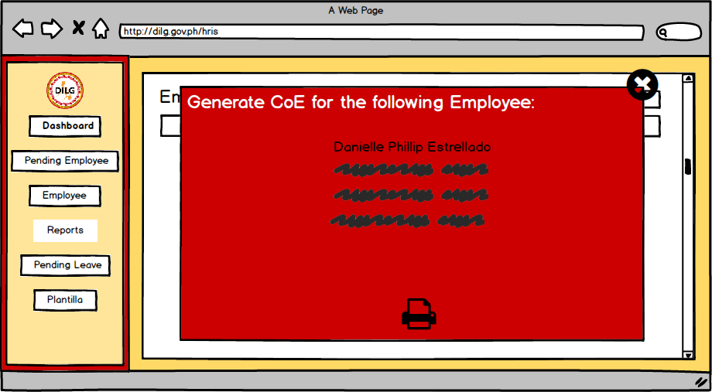

*Figure 20: Reports Certificate of Employment*

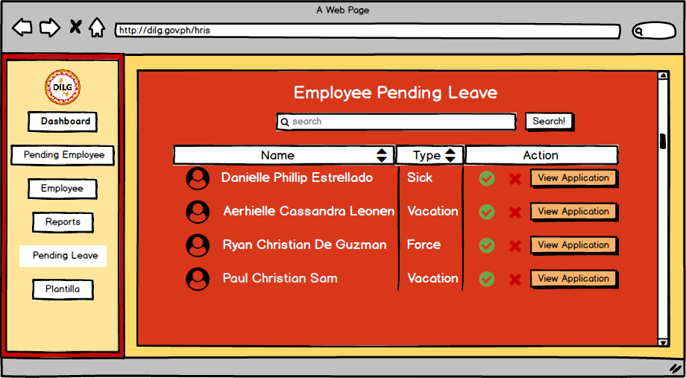

*Figure 21: Pending Leave - The interface where the HR can accept or reject the leaves filled by the employee.*

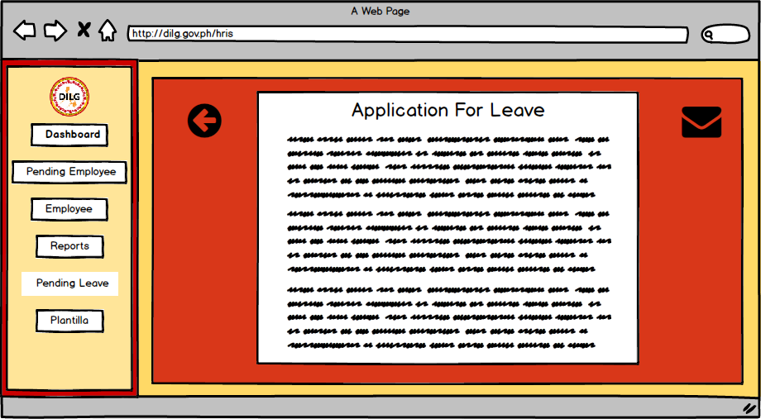

*Figure 22: Application for Leave*

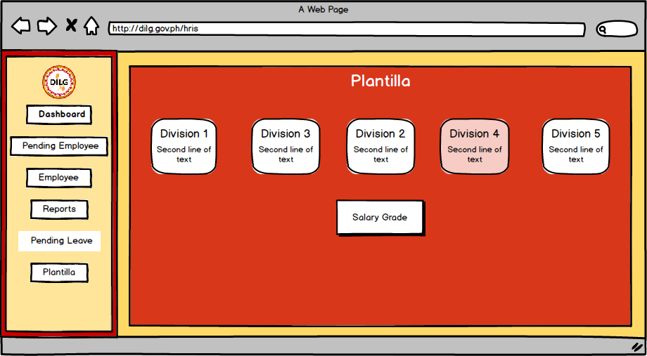

*Figure 23: Plantilla - The divisions of Plantilla*

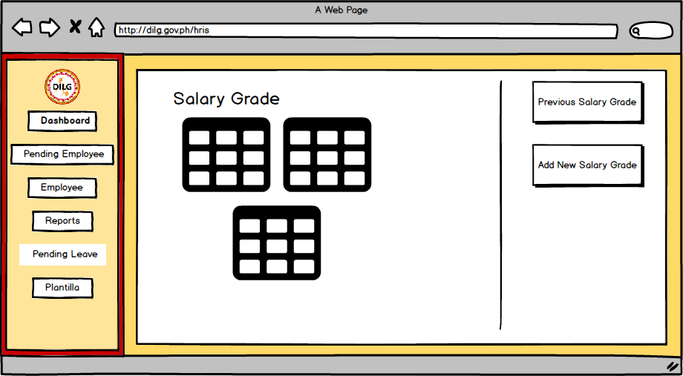

*Figure 24: Plantilla Salary Grade*

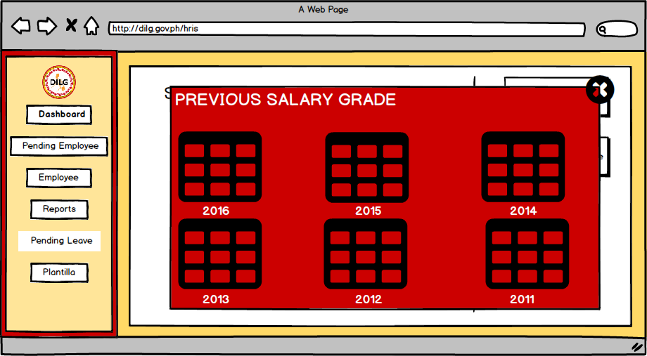

*Figure 25: Previous Salary Grade*

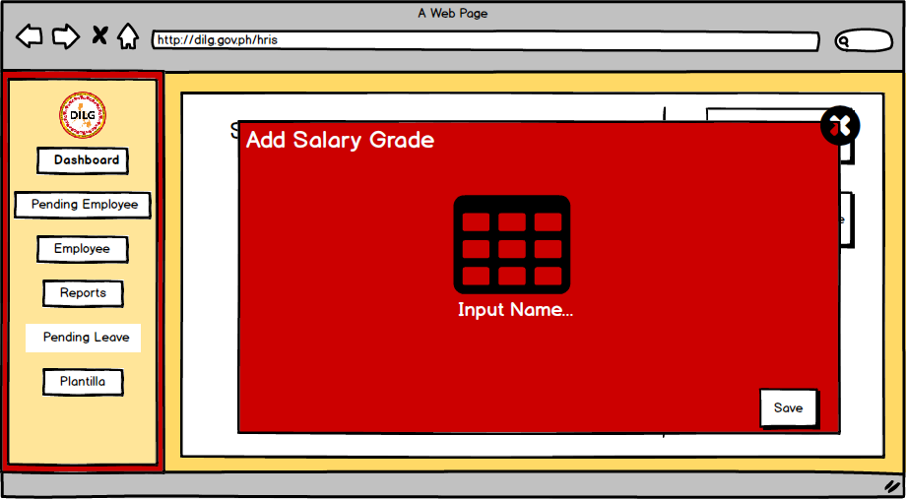

*Figure 26: Addition of Salary Grade - This interface is where the HR can add new Salary grade for the updated version of Salary Grade.*

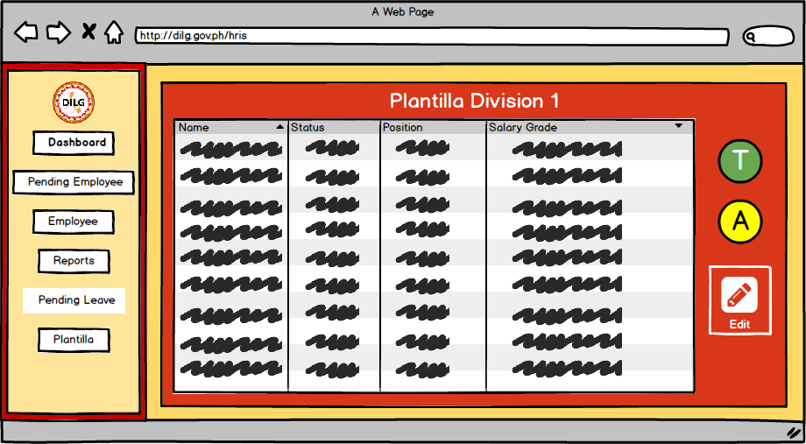

*Figure 27: Plantilla Division*

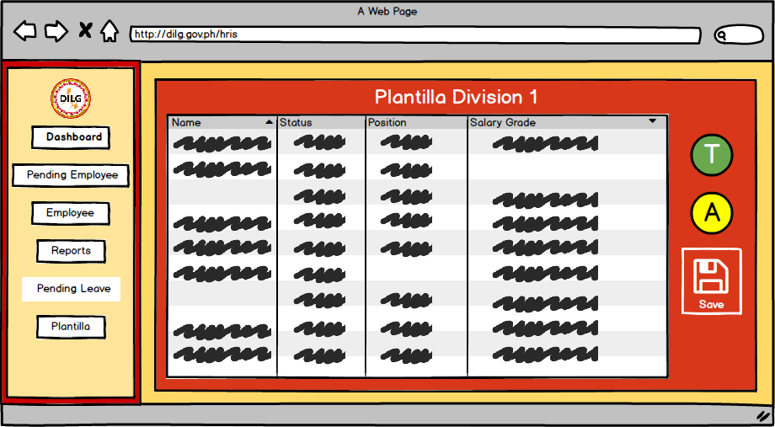

*Figure 28: Editing of Plantilla*

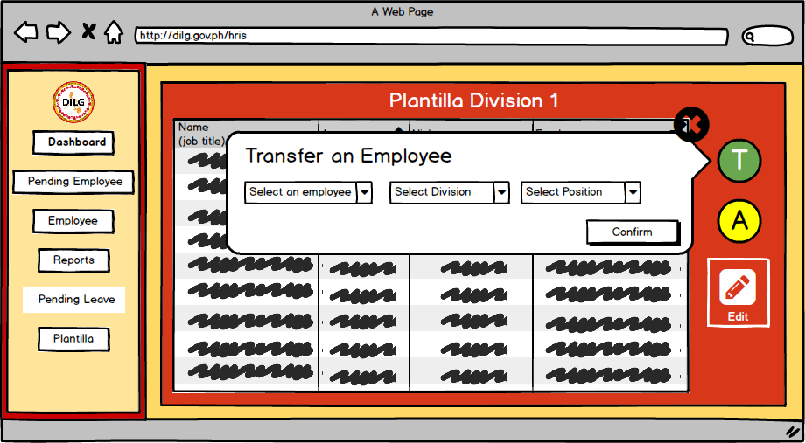

*Figure 29: Plantilla Re-assign - In this interface the HR can Re-assign the employee’s position*

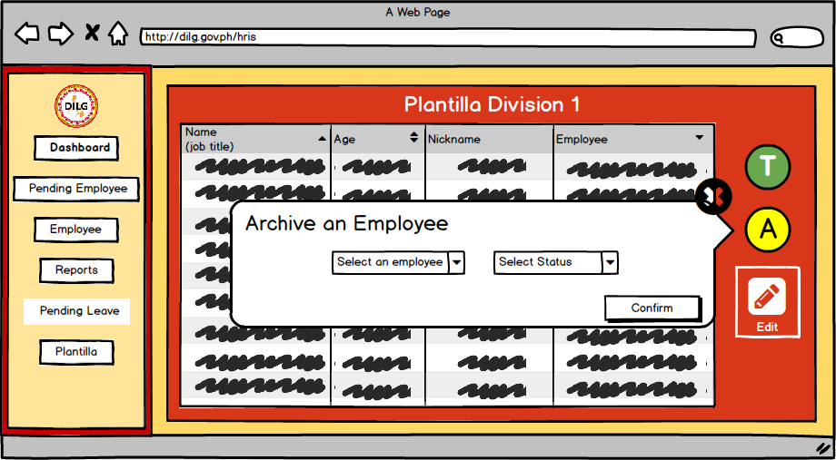

*Figure 30: Archiving an Employee - In this interface the HR can archive the file of the employee depending on the status of the employee.*

**3.5.2 Employee**

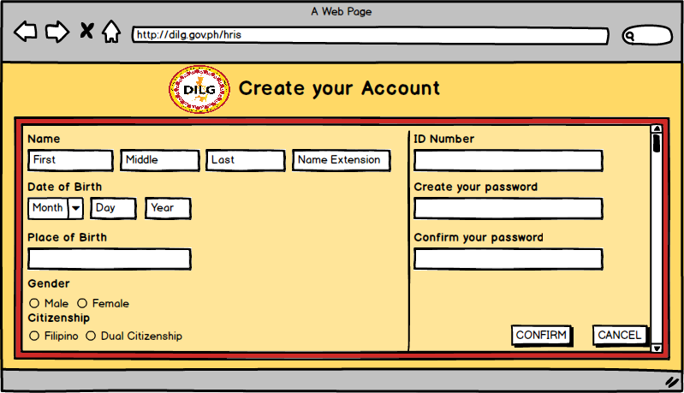

*Figure 31 : Sign Up*

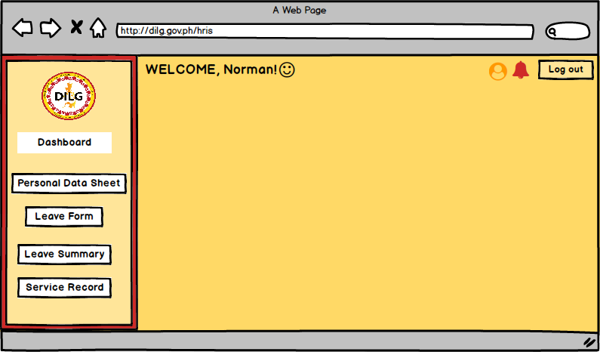

*Figure 32: Dashboard*

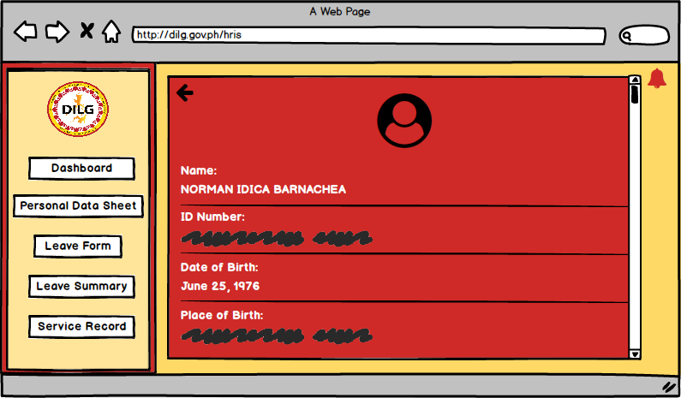

*Figure 33: Profile*

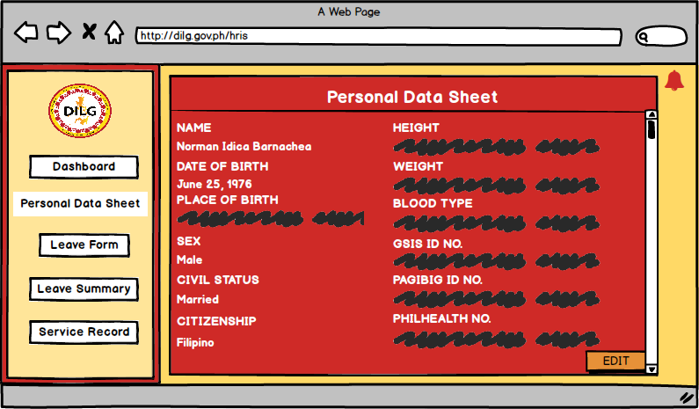

*Figure 34: Personal Data Sheet*

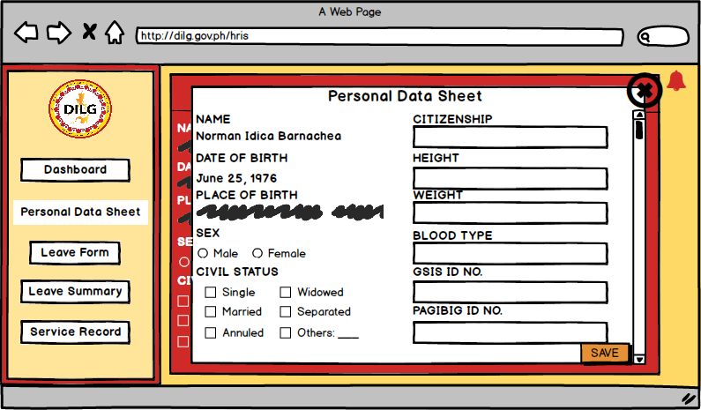

*Figure 35: Edit Personal Data Sheet*

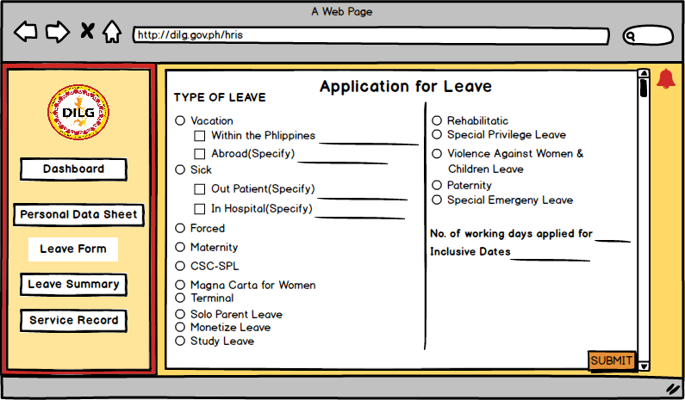

*Figure 36: Application Leave Form*

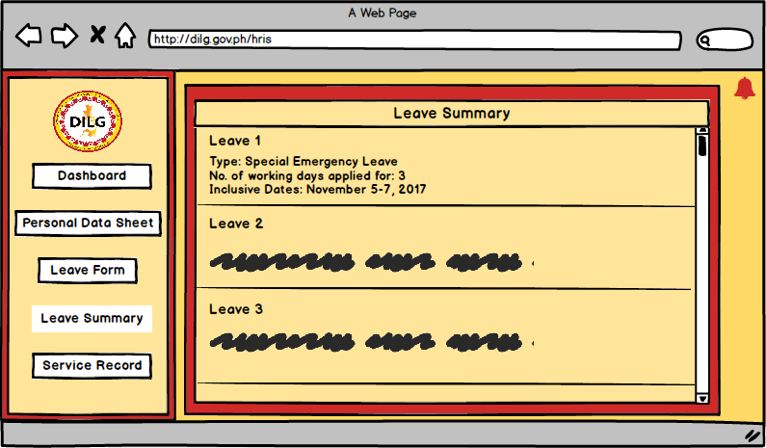

*Figure 37: Leave Summary*

*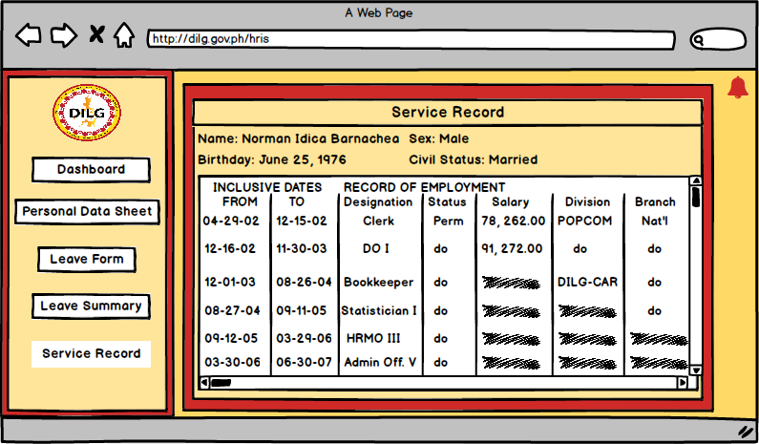Figure 38: Service Record*

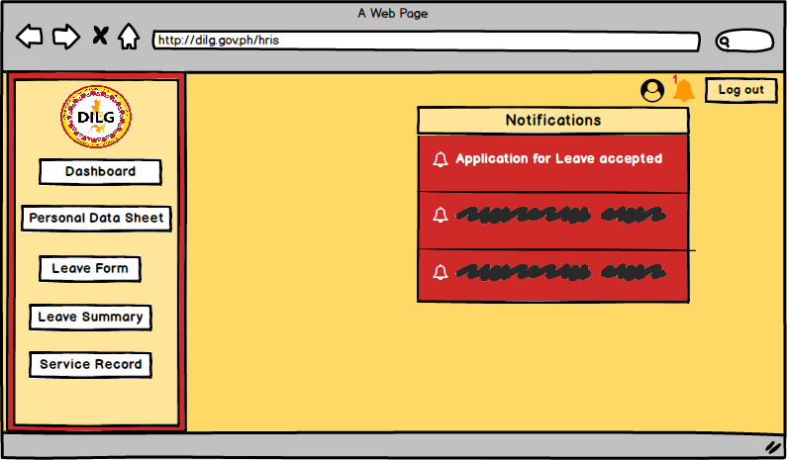

*Figure 39: Notification*

**3.5.3 Super User**

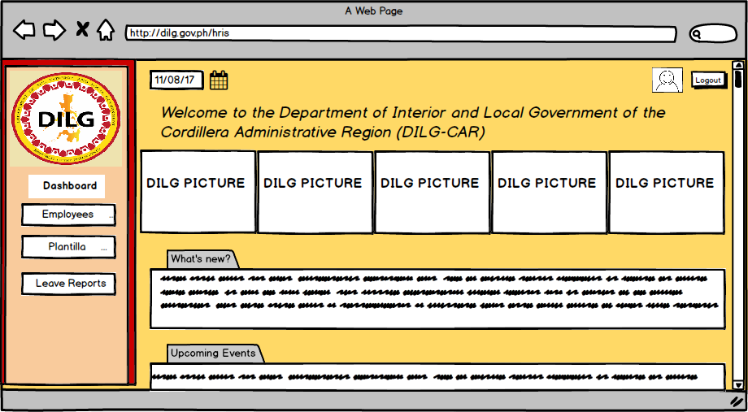

*Figure 40: Dashboard*

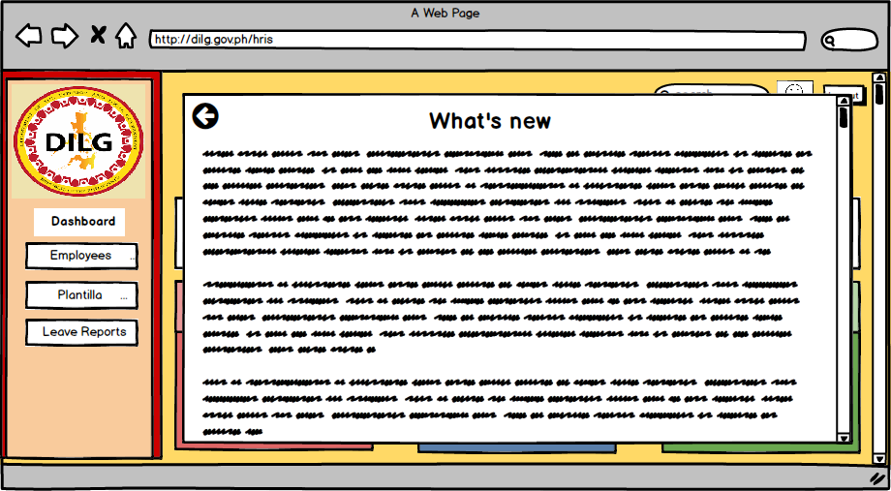

*Figure 41: Dashboard*

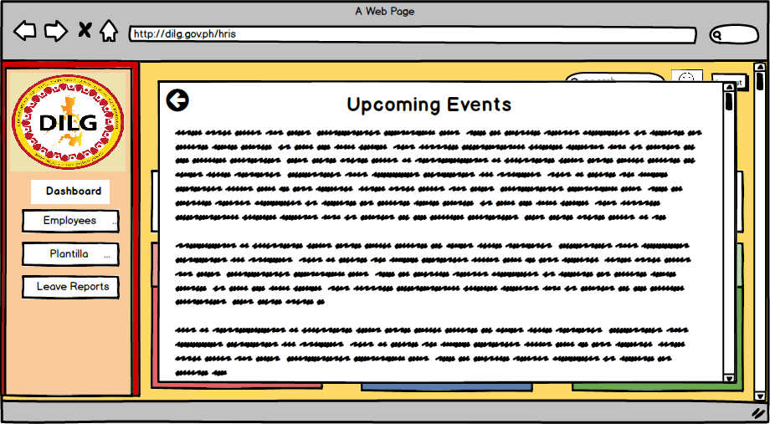

*Figure 42:Dashboard*

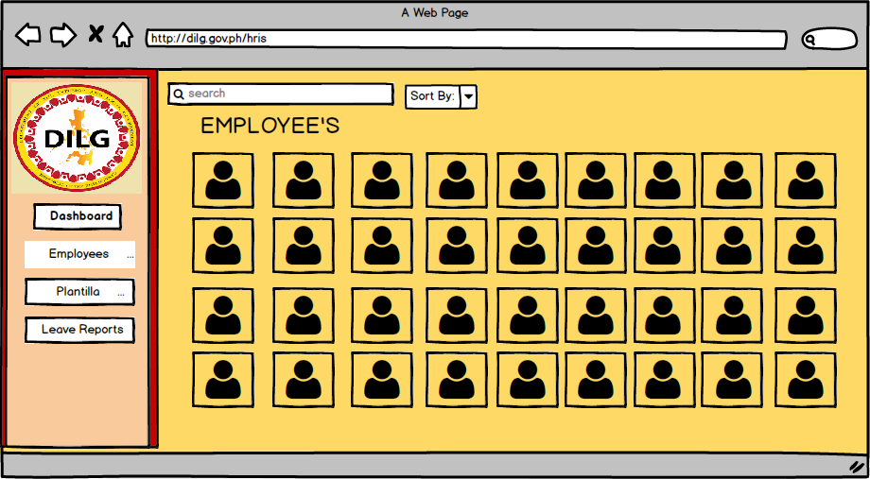

*Figure 43: List of employee - Admin can choose an employee*

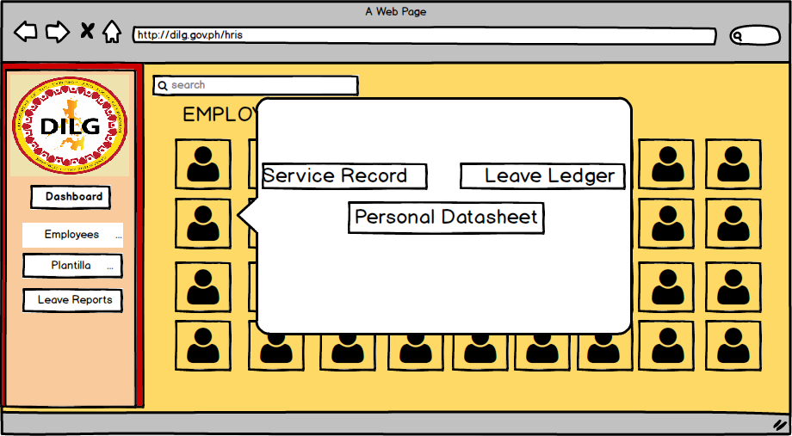

*Figure 44: Employee form - In this interface admin can choose what employee’s information to view*

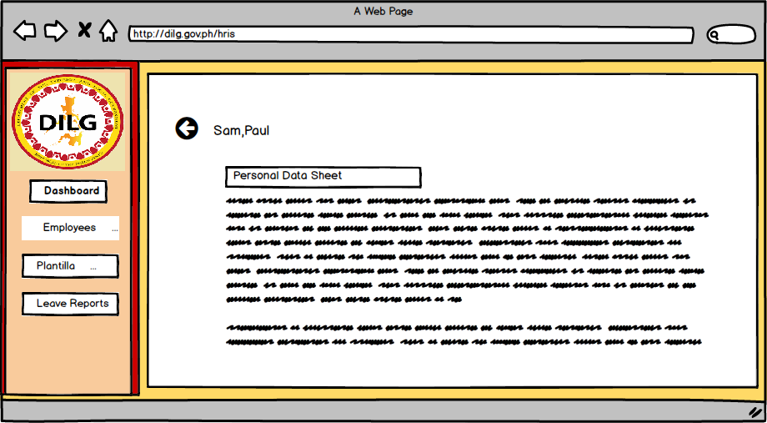

*Figure 45: Employee’s Personal Data Sheet*

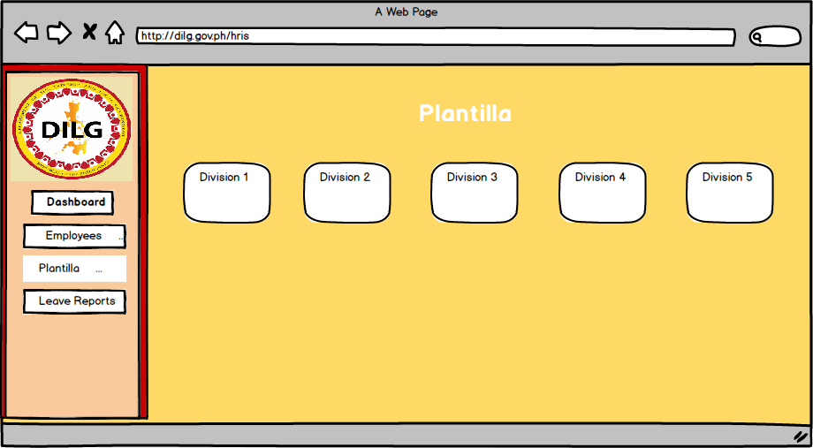

*Figure 46: Plantilla division*

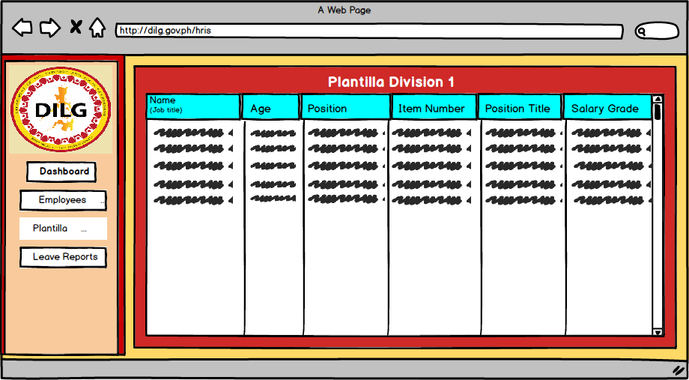

*Figure 47: Plantilla*

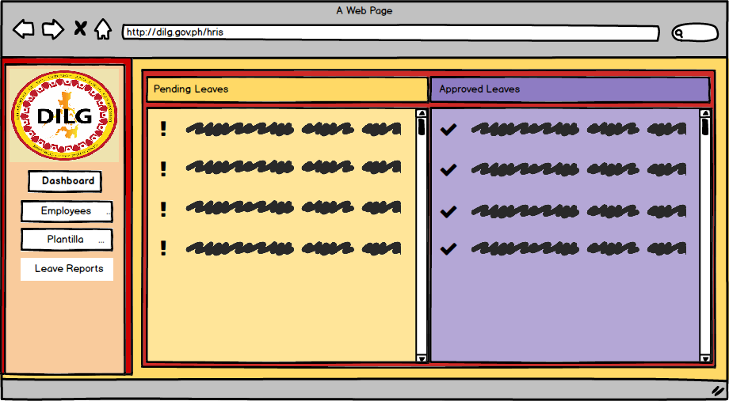

*Figure 48: Pending and Approved Leaves*

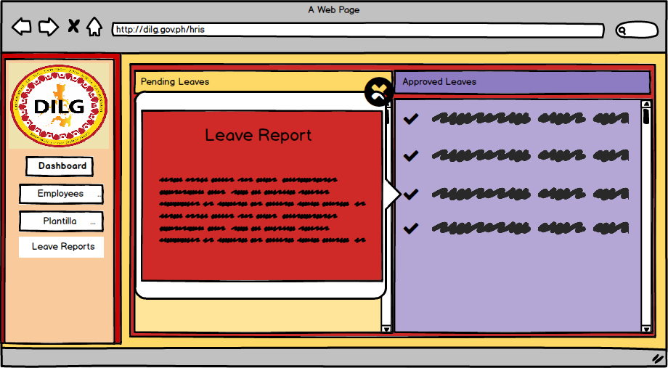

*Figure 49: Leave Report*

**APPENDIX**

**Appendix A:** Daily Time Record

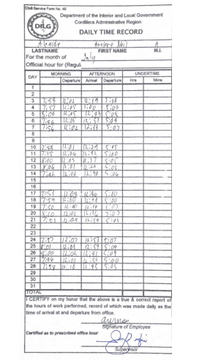

**Appendix B:** Type of Leaves

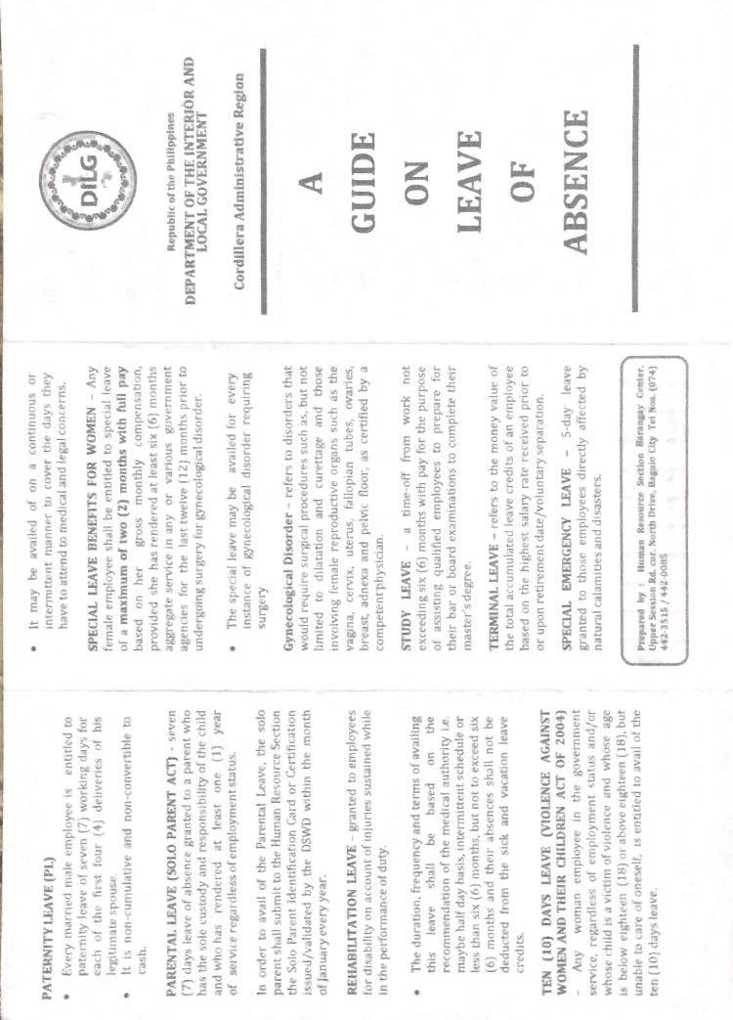

**Appendix C:** Type of Leaves

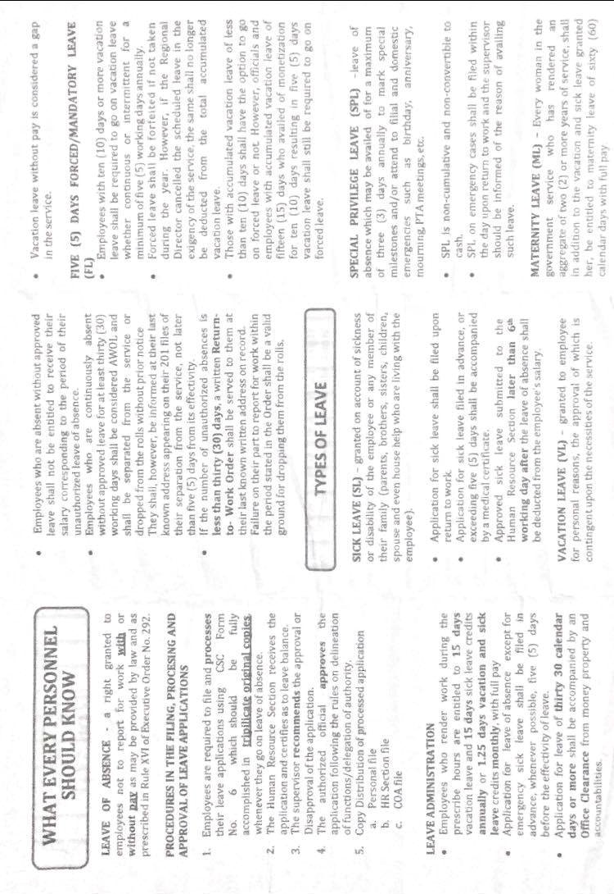

**Appendix D:** Application for Leave Form

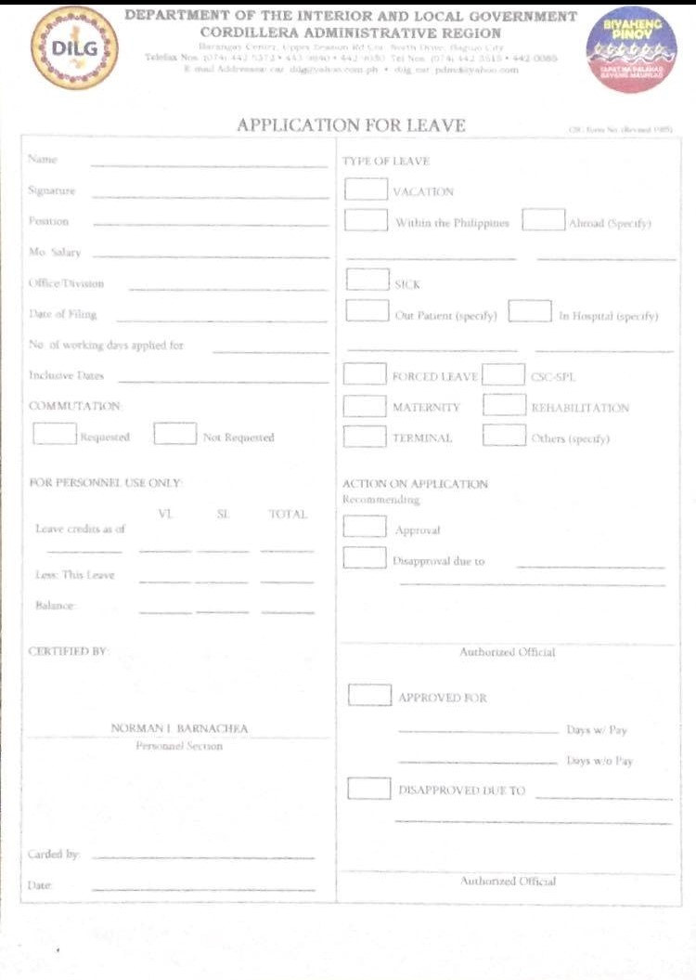

**Appendix E:** Computation of Leaves Credit

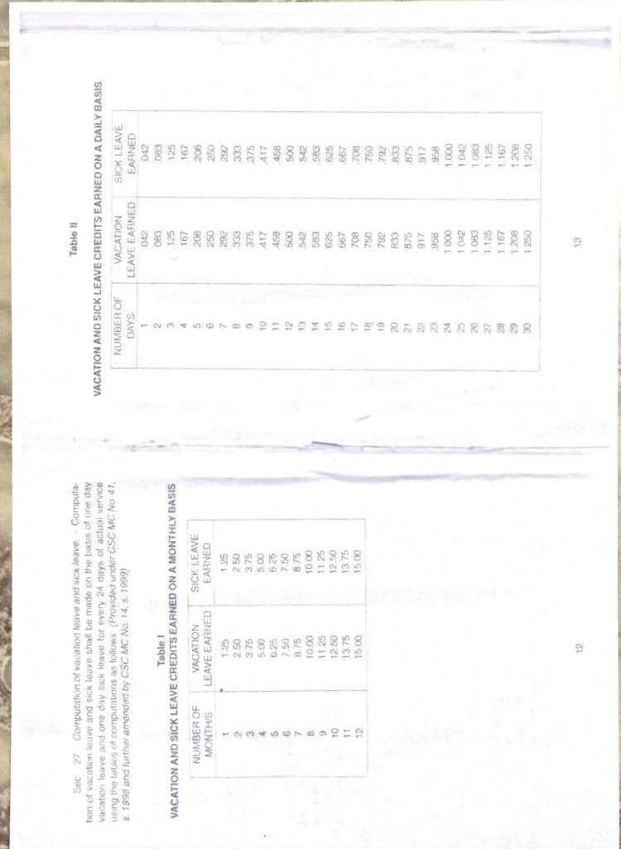

**Appendix F:** Computation of Leaves Credit

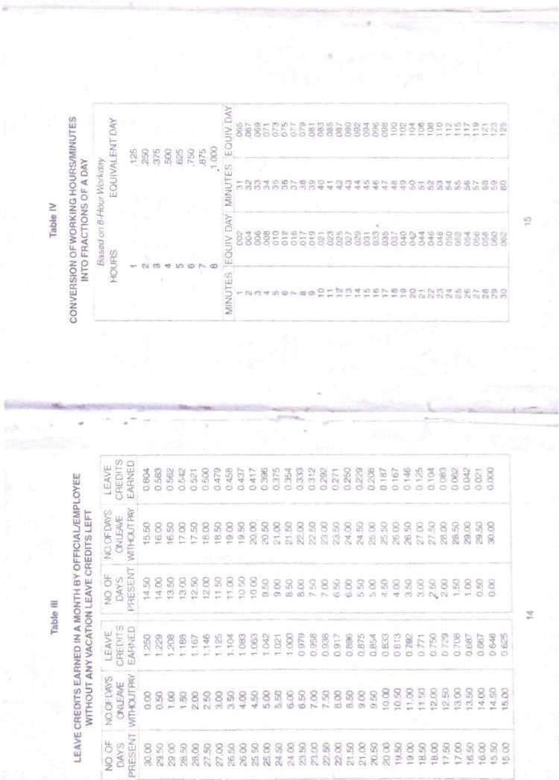

**Appendix G:** Service Record

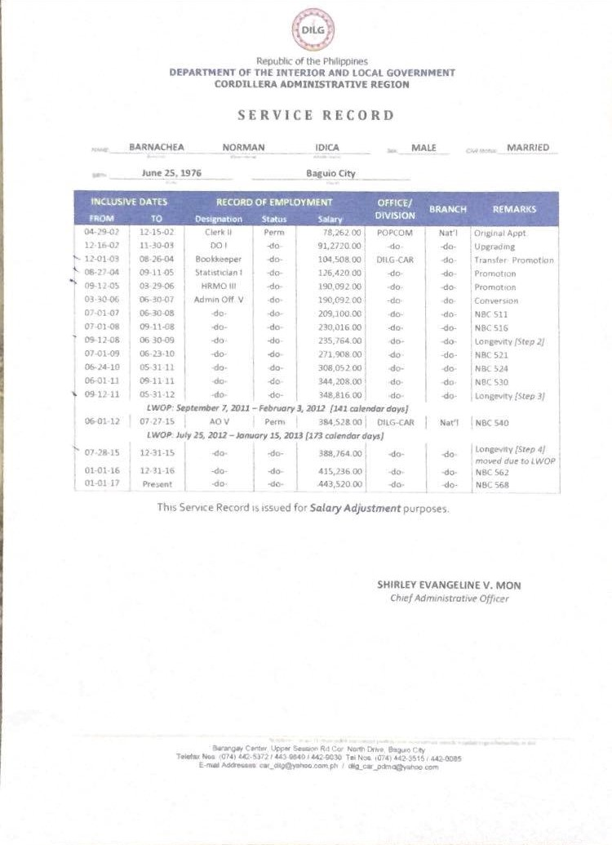

**Appendix H:** Notice of Step Increment

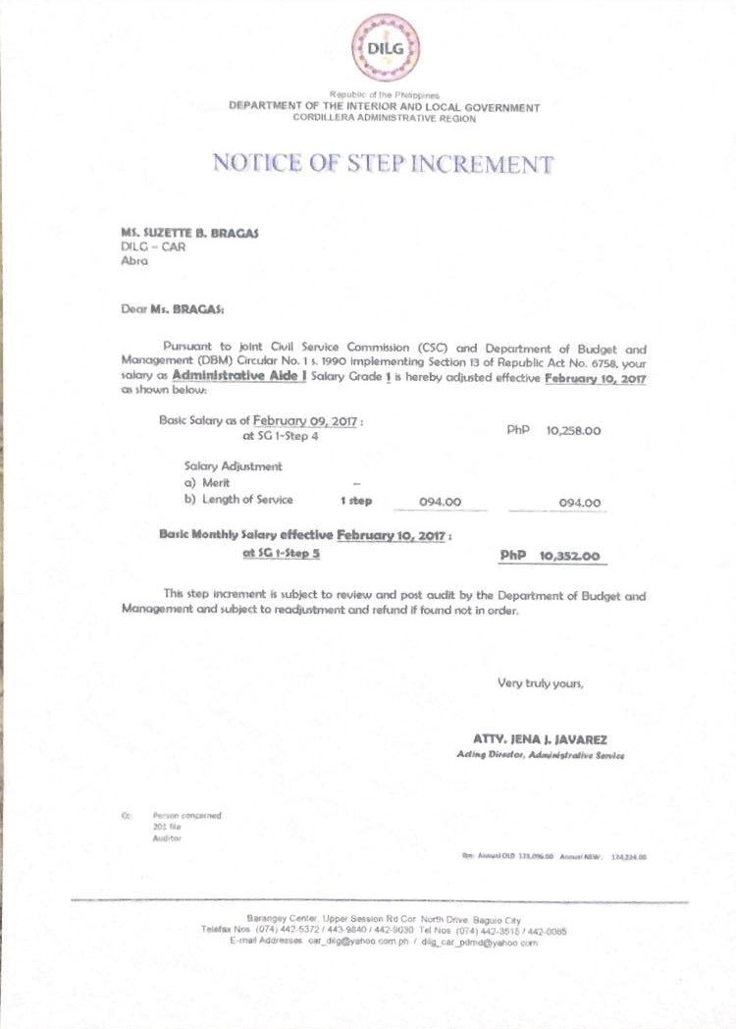

**Appendix I:** Notice of Salary Adjustment

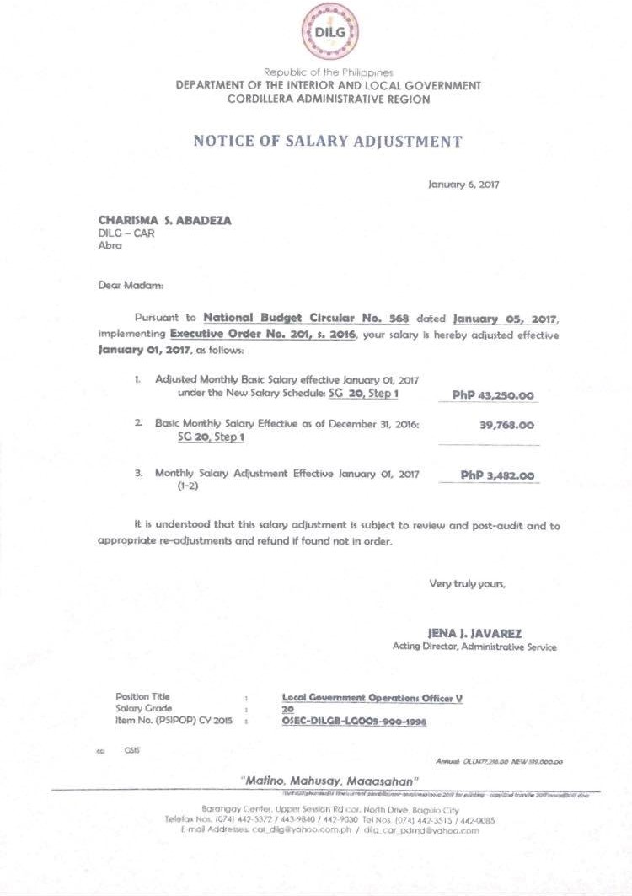

**Appendix J:** Leave Ledger Card

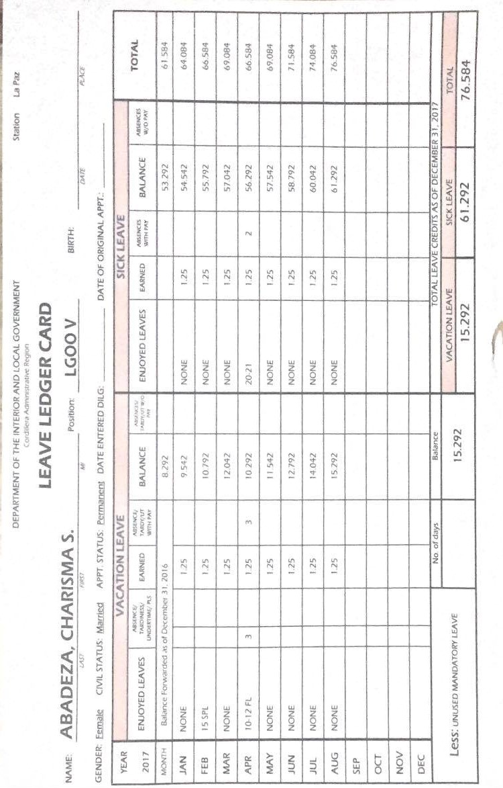

**Appendix K:** Personal Services Itemization and Plantilla of Personnel (Plantilla)

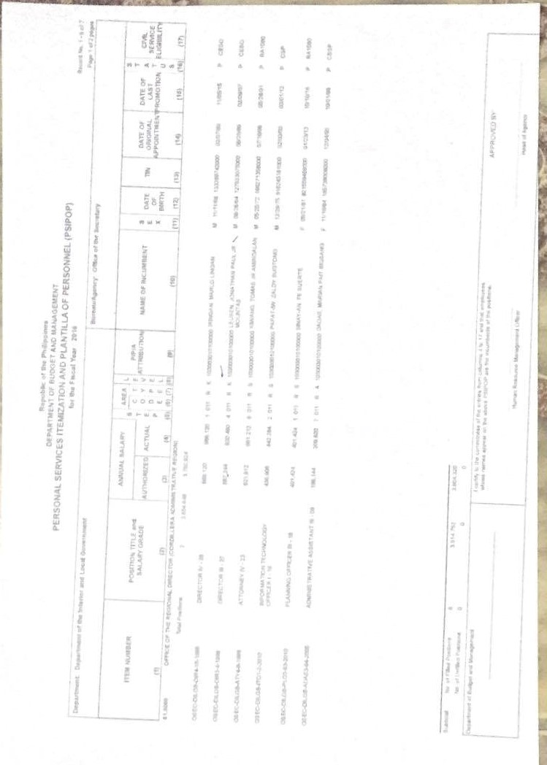

**Appendix L:** Personal Data Sheet

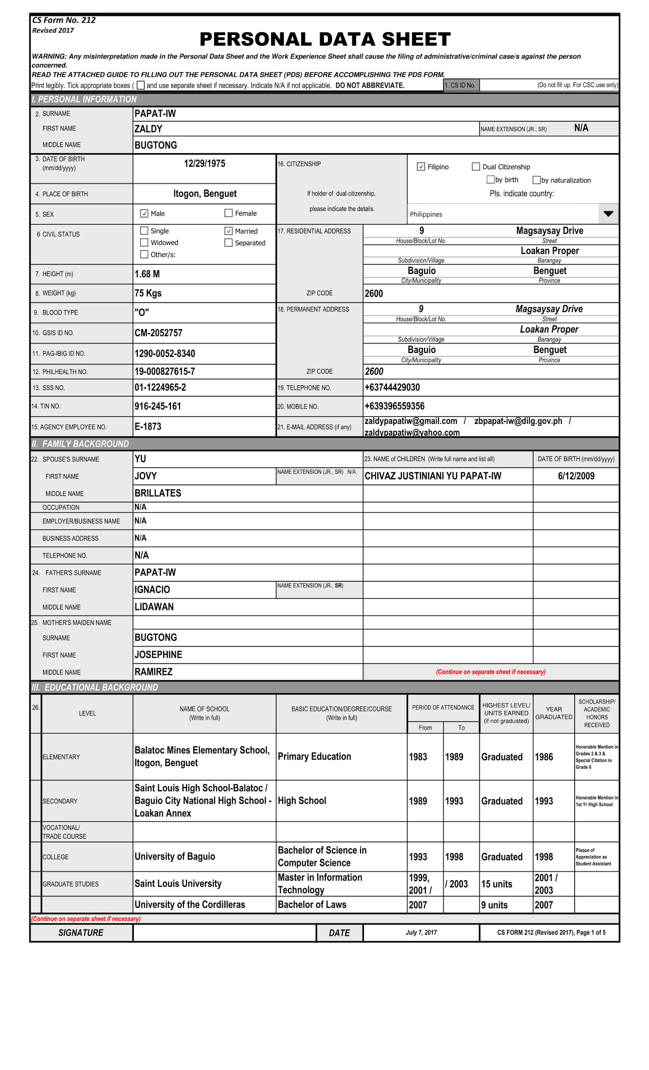

**Appendix M:** Personal Data Sheet

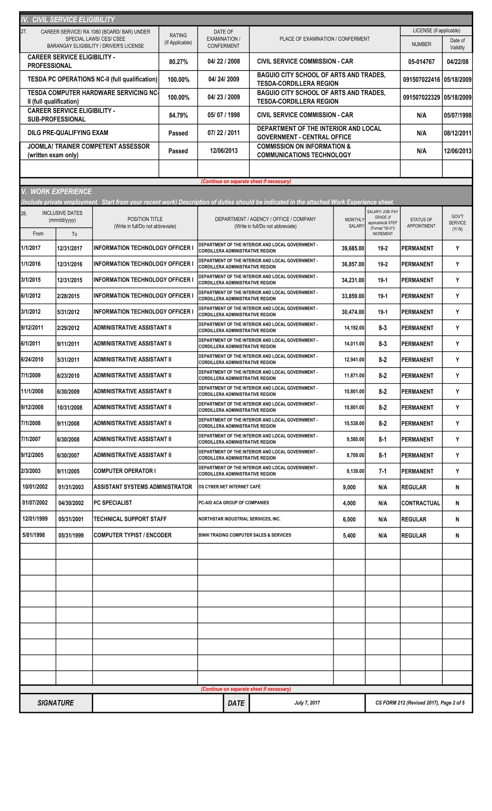

**Appendix N:** Personal Data Sheet

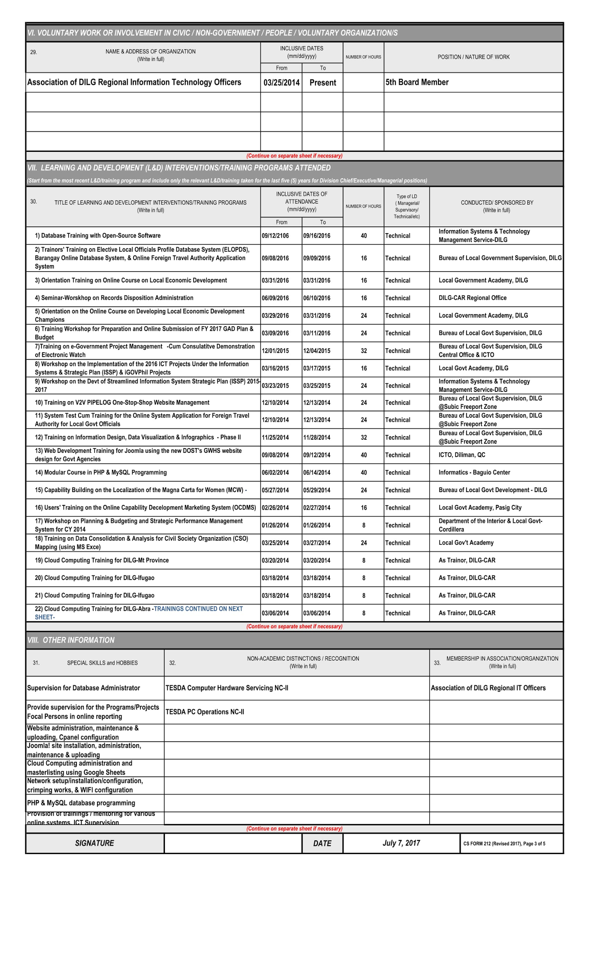

**Appendix O:** Personal Data Sheet

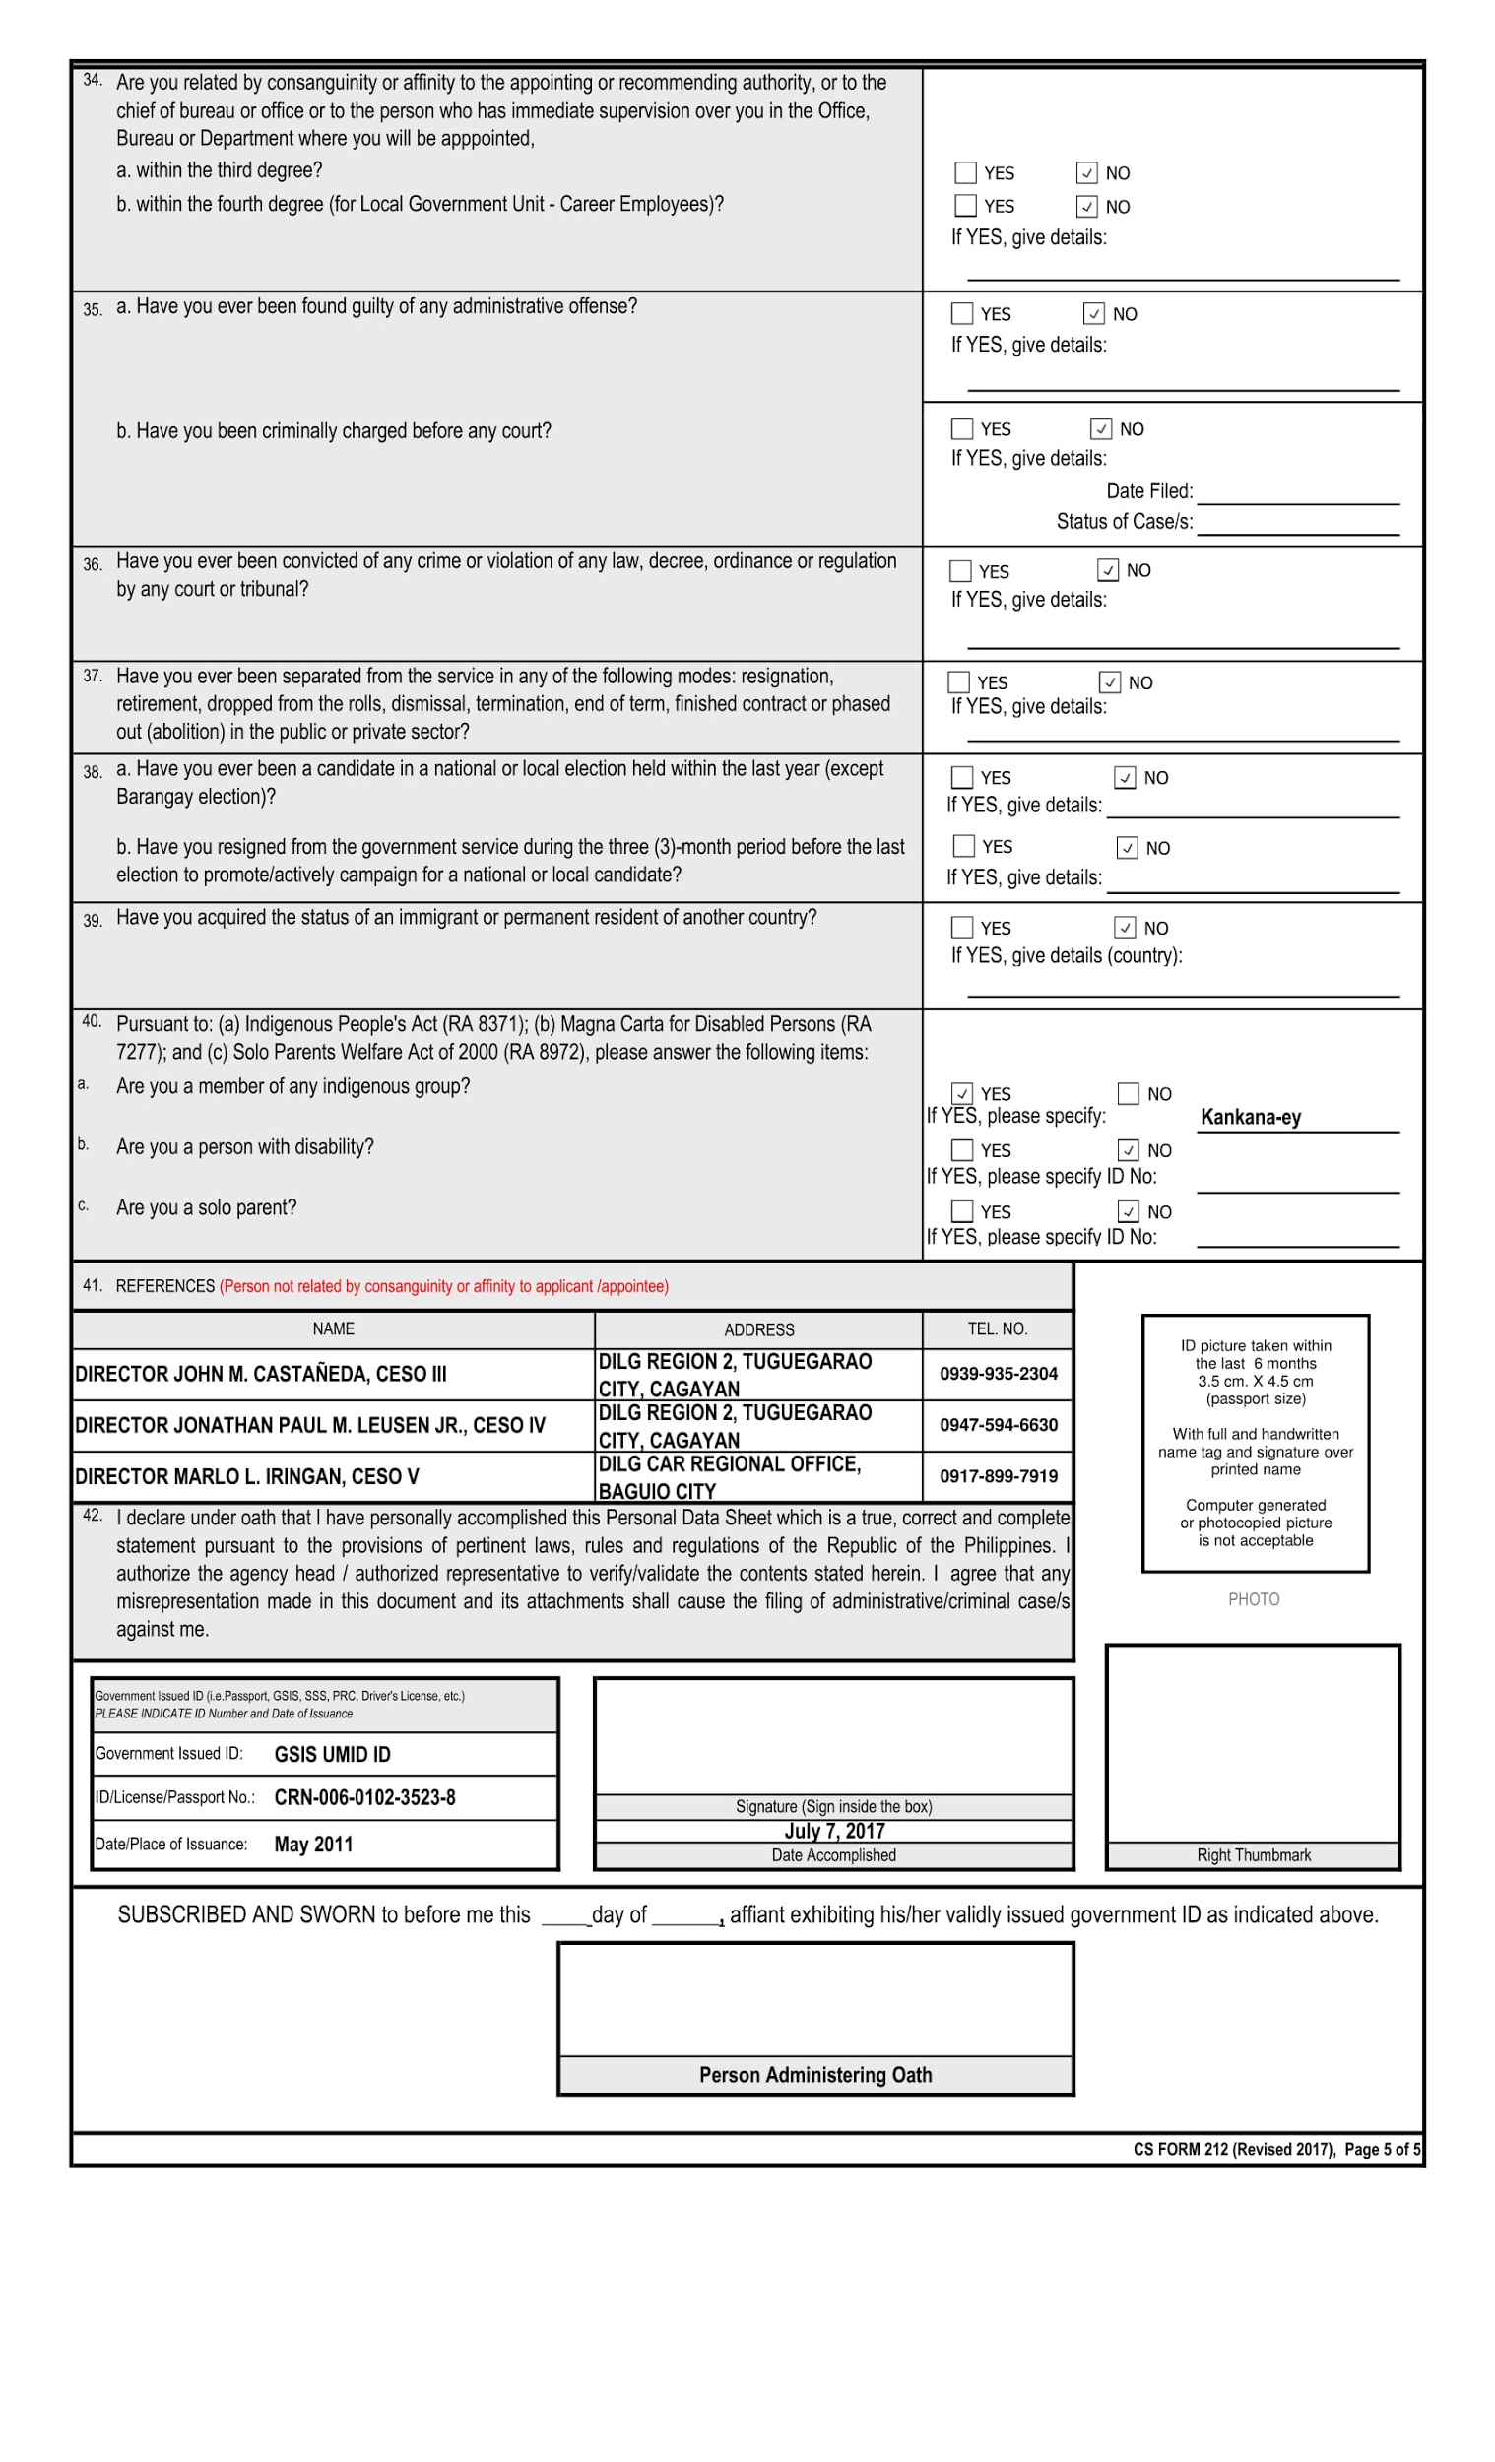

**REFERENCES:**

[1] Human Resources Technology Council (U.S.) and United States Office of Personnel Management. (1997). *Governmentwide human resources information systems study*. Retrieved from

http://www.worldcat.org/title/governmentwide-human-resources-information-systems-study/oclc/38530163&referer=brief_results

[2] Michael J. Kavanagh and Richard D. Johnson. (2014, January 14). *Human Resource Information Systems: Basics, Applications, and Future Directions (4th. ed.)*. Retrieved from

https://books.google.com.ph/books?id=3TxbDgAAQBAJ&pg=PA1&source=gbs_toc_r&cad=2#v=onepage&q&f=false

[3] DILG. (2013). *DEPARTMENT OF INTERIOR AND LOCAL GOVERNMENT: Powers & Functions*. Retrieved from<http://www.dilg.gov.ph/page/Powers-Functions/21>

[4] ISO. *International Organization for Standardization 15489-1:2016: Information and documentation -- Records management -- Part 1: Concepts and principles*. Retrieved from <https://www.iso.org/standard/62542.html>

[5] Rouse, M., Gibilisco, S. (2015, January). *use case diagram (UML use case diagram)*. Retrieved from http://whatis.techtarget.com/definition/use-case-diagram